

**Late Bhausaheb Hiray S.S. Trust’s**

**Institute of Computer Application**

**C E R T I F I C A T E**

This is to certify that **Mr. Amey Arun Padvekar** of MCA Semester - III with Roll No **MCA2022105** has completed all practical’s of **MCAL31 Big Data Analytics and Visualization Lab**under the guidance of **Professor Aquila Shaikh**, in this college during the year 2023-2024.

|  |  |  |  |  |  |
| --- | --- | --- | --- | --- | --- |
| CO | Attendance | Performance during Lab session | Innovation in problem  solving techniques | Mock Viva  during Lab session | Journal |
| CO1 |  |  |  |  |  |
| CO2 |  |  |  |  |  |
| CO3 |  |  |  |  |  |
| CO4 |  |  |  |  |  |

|  |  |
| --- | --- |
| **Subject In-Charge** | **Director** |
| **External Examiner** | |

**Index**

|  |  |  |  |  |
| --- | --- | --- | --- | --- |
|  | **Aim** | **Date** | **CO** | **Sign** |
| 1 | List of Commands (mkdir, touchz, copy from local/put, copy to local/get, move from local, cp, rmr, du, dus, stat) | 23/08/2023 |  |  |
| 2 | Map Reduce:   1. Write a program in Map Reduce for WordCount operation. 2. Write a program in Map Reduce for Union operation. 3. Write a program in Map Reduce for Intersection operation. 4. Write a program in Map Reduce for Grouping and Aggregation. 5. 5. Write a program in Map Reduce for Matrix Multiplication | 08/09/2023 |  |  |
| 3 | MongoDB :   1. Installation 2. Sample Database Creation 3. Query the Sample Database using MongoDB querying commands 4. Create Collection 5. Insert Document 6. Query Document 7. Delete Document e. Indexing | 20/09/2023 |  |  |
| 4 | Hive:   1. Hive Data Types 2. Create Database & Table in Hive 3. Hive Partitioning 4. Hive Built-In Operators 5. Hive Built-In Functions 6. Hive Views and Indexes 7. HiveQL : Select Where, Select OrderBy, Select GroupBy, Select Joins | 10/10/2023 |  |  |
| 5 | Pig:   1. Pig Latin Basic 2. Pig Data Types, 3. Download the data 4. Create your Script 5. Save and Execute the Script 6. Pig Operations : Diagnostic Operators, Grouping and Joining, Combining & Splitting, Filtering, Sorting | 27/10/2023 |  |  |
| 6 | Spark:   1. Downloading Data Set and Processing it Spark 2. Word Count in Apache Spark. | 14/11/2023 |  |  |
| 7 | Visualization using Tableau:  Tableau: Tool Overview, Importing Data, Analyzing with Charts, Creating Dashboards, Working with maps, Telling Stories with tableau. | 12/12/2023 |  |  |

**Subject In-charge Director**

# Practical No 1

**Aim:** HDFS: List of Commands (mkdir, touchz, copy from local/put, copy to local/get, move from local, cp, rmr, du, dus, stat).

1. **-mkdir:** To create a directory.

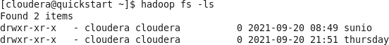

hadoop fs -mkdir /user/cloudera/thursday

1. **-touchz:** It creates an empty file.

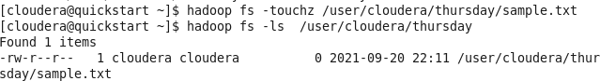

hadoop fs -touchz /user/cloudera/thursday/sample.txt

1. **CopyFromLocal:** To copy files/folders from local file system to hdfs store.

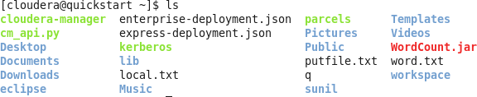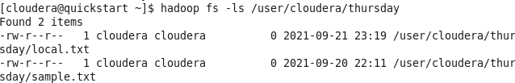

hadoop fs -copyFromLocal local.txt /user/cloudera/thursday

1. **put**

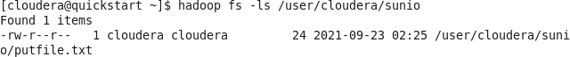

hadoop fs -put /home/cloudera/putfile.txt /user/cloudera/thursday

1. **CopyToLocal:** To Copy files/folders from hdfs store to local file system.

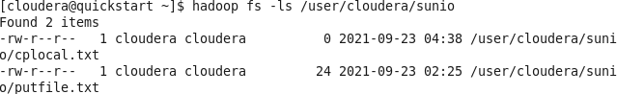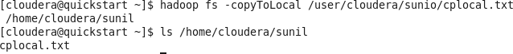

hadoop fs -copyToLocal /user/cloudera/sunio/cplocal.txt /home/cloudera/sunil

### get

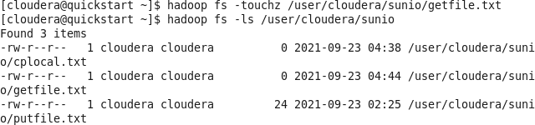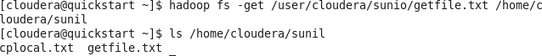

hadoop fs -get /user/cloudera/sunio/getfile.txt /home/cloudera/sunil

1. **moveFromLocal:** This command will move file from local to hdfs.



hadoop fs -moveFromLocal /home/cloudera/sunil/mvfromlocal.txt /user/cloudera/sunio

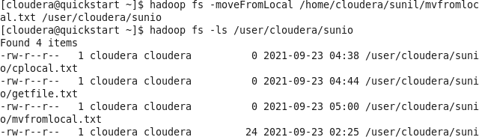



1. **cp:** This command is used to copy files within hdfs.

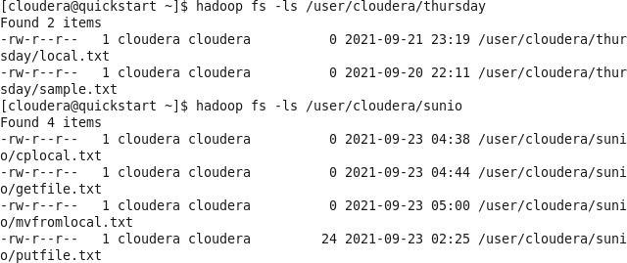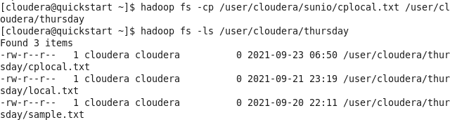

hadoop fs -cp /user/cloudera/sunio/cplocal.txt /user/cloudera/sunio

1. **rmr:** This Command delete a file from HDFS recursively.



hadoop fs -rmr /user/cloudera/thursday

1. **du:** It will give the size of each file in directory.

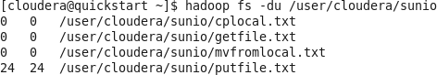

hadoop fs -du /user/cloudera/sunio

1. **dus:** This command will give the total size of the directory/file.



hadoop fs -dus /user/cloudera/sunio

1. **stat:** It will give the last modified time of directory or path.



hadoop fs -stat /user/cloudera/sunio

# Practical No 2

**Aim:** Write a program in Map Reduce for Word Count operation.

**Code:**

import java.io.IOException; import java.util.StringTokenizer;

import org.apache.hadoop.conf.Configuration; import org.apache.hadoop.fs.Path;

import org.apache.hadoop.io.IntWritable; import org.apache.hadoop.io.Text;

import org.apache.hadoop.mapreduce.Job; import org.apache.hadoop.mapreduce.Mapper; import org.apache.hadoop.mapreduce.Reducer;

import org.apache.hadoop.mapreduce.lib.input.FileInputFormat; import org.apache.hadoop.mapreduce.lib.output.FileOutputFormat;

public class WordCount

{

public static class TokenizerMapper extends Mapper<Object, Text, Text, IntWritable>

{

private final static IntWritable one=new IntWritable(1); private Text word=new Text();

public void map(Object key,Text Value,Context context)throws IOException,InterruptedException

{

StringTokenizer itr=new StringTokenizer(Value.toString()); while(itr.hasMoreTokens())

{

word.set(itr.nextToken());

context.write(word, one);

}

}

}

public static class IntSumReducer extends Reducer<Text, IntWritable,Text,IntWritable>

{

private IntWritable result=new IntWritable();

public void reduce(Text key,Iterable<IntWritable>values,Context context)throws IOException,InterruptedException

{

int sum=0;

for(IntWritable val:values)

{

sum=sum+val.get();

}

result.set(sum); context.write(key, result);

}

}

public static void main(String[] args)throws Exception

{

Configuration conf=new Configuration(); Job job=Job.getInstance(conf,"word count"); job.setJarByClass(WordCount.class); job.setMapperClass(TokenizerMapper.class); job.setReducerClass(IntSumReducer.class); job.setCombinerClass(IntSumReducer.class); job.setOutputKeyClass(Text.class); job.setOutputValueClass(IntWritable.class);

FileInputFormat.addInputPath(job,new Path(args[0])); FileOutputFormat.setOutputPath(job, new Path(args[1])); System.exit(job.waitForCompletion(true)?0:1);

}

}

### Input File:

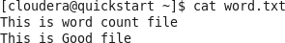

**Output:**

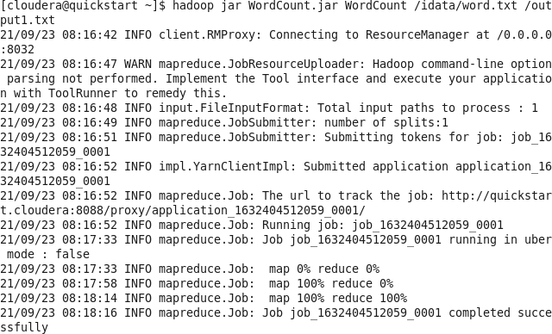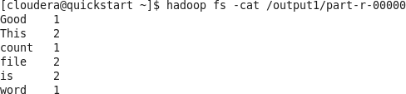

hadoop jar WordCounr.jar WordCount /idata/word.txt/output1.txt

hadoop fs -cat /output1/part-r-00000

**Aim:** Write a program in Map Reduce for Union operation.

### Code:

import java.io.*;

import java.util.StringTokenizer;

import org.apache.hadoop.conf.Configuration; import org.apache.hadoop.fs.Path;

import org.apache.hadoop.fs.FileSystem; import org.apache.hadoop.io.LongWritable; import org.apache.hadoop.io.IntWritable; import org.apache.hadoop.io.Text;

import org.apache.hadoop.mapreduce.Job; import org.apache.hadoop.mapreduce.Mapper; import org.apache.hadoop.mapreduce.Reducer;

import org.apache.hadoop.mapreduce.lib.input.MultipleInputs; import org.apache.hadoop.mapreduce.lib.input.TextInputFormat; import org.apache.hadoop.mapreduce.lib.input.FileInputFormat; import org.apache.hadoop.mapreduce.lib.output.FileOutputFormat; import org.apache.hadoop.util.GenericOptionsParser;

public class Union {

public static class MultipleMaps extends Mapper<LongWritable,Text,Text,IntWritable>

{

private final static IntWritable one=new IntWritable(1); private Text keyEmit=new Text();

public void map(LongWritable k,Text value,Context context)throws IOException, InterruptedException

{

StringTokenizer itr=new StringTokenizer(value.toString()); while(itr.hasMoreElements())

{

keyEmit.set(itr.nextToken()); context.write(keyEmit, one);

}

}

}

public static class MultipleReducer extends Reducer<Text,IntWritable,Text,IntWritable>

{

private IntWritable result=new IntWritable();

public void reduce(Text key,Iterable<IntWritable>values,Context context)throws IOException, InterruptedException

{

int sum=0; for(IntWritable val:values)

{

sum +=val.get();

}

result.set(sum); context.write(key, result);

}

}

public static void main(String[] args)throws Exception

{

if(args.length!=3)

{

System.err.println("No of arguments should be 3"); System.exit(0);

}

Configuration c=new Configuration();

String[] files=new GenericOptionsParser(c,args).getRemainingArgs(); Path p1=new Path(files[0]);

Path p2=new Path(files[1]); Path p3=new Path(files[2]); FileSystem fs=FileSystem.get(c);

if(fs.exists(p3)){

fs.delete(p3,true);

}

Job job=Job.getInstance(c,"Union"); job.setJarByClass(Union.class);

MultipleInputs.addInputPath(job,p1,TextInputFormat.class,MultipleMaps.class); MultipleInputs.addInputPath(job,p2,TextInputFormat.class,MultipleMaps.class);

job.setReducerClass(MultipleReducer.class); job.setCombinerClass(MultipleReducer.class); job.setOutputKeyClass(Text.class); job.setOutputValueClass(IntWritable.class);

FileOutputFormat.setOutputPath(job, p3); boolean success=job.waitForCompletion(true); System.exit(success?0:1);

}

}

### Input File:

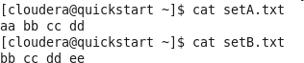

**Output:**

hadoop jar Union.jar Union /user/cloudera/inputfile/SetA.txt /user/cloudera/inputfile/SetB.txt

/output_union

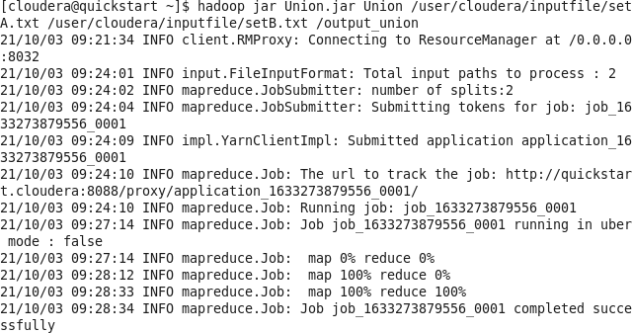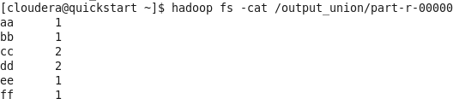

hadoop fs -cat /output_union/part-r-00000

**Aim:** Write a program in Map Reduce for Intersection operation.

import java.io.*;

import java.util.StringTokenizer;

import org.apache.hadoop.conf.Configuration; import org.apache.hadoop.fs.Path;

import org.apache.hadoop.fs.FileSystem; import org.apache.hadoop.io.LongWritable; import org.apache.hadoop.io.IntWritable; import org.apache.hadoop.io.Text;

import org.apache.hadoop.mapred.TextInputFormat; import org.apache.hadoop.mapreduce.Job;

import org.apache.hadoop.mapreduce.Mapper; import org.apache.hadoop.mapreduce.Reducer;

import org.apache.hadoop.mapreduce.lib.input.MultipleInputs; import org.apache.hadoop.mapreduce.lib.input.FileInputFormat; import org.apache.hadoop.mapreduce.lib.output.FileOutputFormat; import org.apache.hadoop.util.GenericOptionsParser;

import org.apache.hadoop.util.Tool;

import org.apache.hadoop.util.ToolRunner;

public class Difference1 {

public static class MultipleMapA extends Mapper<LongWritable,Text,Text,Text>

{

private Text keyEmit=new Text(); private Text valEmit=new Text("A");

public void map(LongWritable k,Text value,Context context)throws IOException, InterruptedException

{

StringTokenizer itr=new StringTokenizer(value.toString()); while(itr.hasMoreTokens())

{

keyEmit.set(itr.nextToken()); context.write(keyEmit, valEmit);

}

}

}

public static class MultipleMapB extends Mapper<LongWritable,Text,Text,Text>

{

private Text keyEmit=new Text(); private Text valEmit=new Text("B");

public void map(LongWritable k,Text value,Context context)throws IOException, InterruptedException

{

StringTokenizer itr=new StringTokenizer(value.toString()); while(itr.hasMoreTokens())

{

keyEmit.set(itr.nextToken()); context.write(keyEmit, valEmit);

}

}

}

public static class MultipleReducer extends Reducer<Text,Text,Text,Text>

{

private Text valEmit=new Text("");

public void Reduce(Text key,Iterable<Text> values,Context context)throws IOException, InterruptedException

{

boolean flag=true; for(Text val:values)

{

if(val.toString().contains("B")){

flag=false; break;

}

}

if(flag){

context.write(key, valEmit);

}

}

}

public static void main(String[] args)throws Exception

{

if(args.length!=3){

System.err.println("No of arguments should be 3"); System.exit(0);

}

Configuration c=new Configuration();

String[] files=new GenericOptionsParser(c,args).getRemainingArgs(); Path p1=new Path(files[0]);

Path p2=new Path(files[1]); Path p3=new Path(files[2]);

FileSystem fs=FileSystem.get(c); if(fs.exists(p3)){

fs.delete(p3,true);

}

Job job=Job.getInstance(c,"Difference1"); job.setJarByClass(Difference1.class); MultipleInputs.addInputPath(job, p1,

TextInputFormat.class,MultipleMapA.class);

MultipleInputs.addInputPath(job, p2, TextInputFormat.class,MultipleMapB.class);

job.setReducerClass(MultipleReducer.class);

job.setOutputKeyClass(Text.class); job.setOutputValueClass(Text.class); FileOutputFormat.setOutputPath(job, p3); if(!job.waitForCompletion(true))

{

System.exit(1);

}

}

}

### Input File:



**Output:**

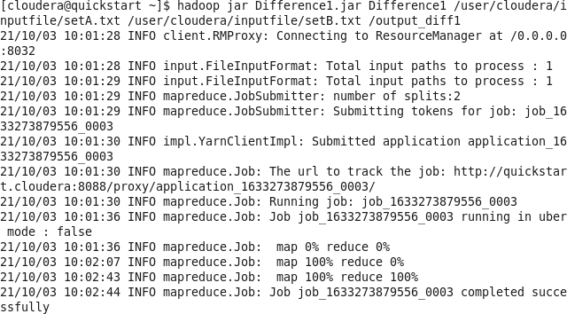

hadoop jar Difference1.jar Difference1 /user/cloudera/inputfile/setA.txt

/user/cloudera/inputfile/setB.txt /output_diff1

hadoop fs -cat /output_diff1/part-r-00000

**Aim:** Write a program in Map Reduce for Grouping and Aggregation.

import java.io.IOException; import java.io.IOException.*; import org.apache.hadoop.io.*; import org.apache.hadoop.io.Text; import org.apache.hadoop.fs.Path; import org.apache.hadoop.conf.*;

import org.apache.hadoop.mapreduce.*;

import org.apache.hadoop.mapreduce.lib.input.FileInputFormat; import org.apache.hadoop.mapreduce.lib.output.FileOutputFormat; import org.apache.hadoop.mapreduce.lib.input.TextInputFormat; import org.apache.hadoop.mapreduce.lib.output.TextOutputFormat;

public class AvgGroup {

public static class Mapavg extends Mapper<LongWritable, Text, Text, IntWritable>

{

private Text gender=new Text();

private IntWritable age=new IntWritable();

public void map(LongWritable key,Text value,Context context)throws IOException, InterruptedException

{

String line=value.toString(); String str[]=line.split(","); if(str.length>6)

{

gender.set(str[4]); if(str[1].equals("0"))

{

if(str[5].matches("\\d+"))

{

int i=Integer.parseInt(str[5]); age.set(i);

}

}

}

context.write(gender,age);

}

}

public static class Reduceavg extends Reducer<Text, IntWritable, Text, IntWritable>

{

public void reduce(Text key, Iterable<IntWritable>values, Context context)throws IOException, InterruptedException

{

int sum=0; int l=0;

for(IntWritable val:values)

{

l+=1;

sum+=val.get();

}

sum=sum/l;

context.write(key, new IntWritable(sum));

}

}

public static void main(String[] args)throws Exception

{

Configuration conf=new Configuration(); Job job=Job.getInstance(conf,"AvgGroup"); job.setJarByClass(AvgGroup.class);

job.setMapOutputKeyClass(Text.class); job.setMapOutputValueClass(IntWritable.class); job.setOutputKeyClass(Text.class); job.setOutputValueClass(IntWritable.class); job.setMapperClass(Mapavg.class); job.setReducerClass(Reduceavg.class); job.setCombinerClass(Reduceavg.class); job.setInputFormatClass(TextInputFormat.class); job.setOutputFormatClass(TextOutputFormat.class); FileInputFormat.addInputPath(job,new Path(args[0])); FileOutputFormat.setOutputPath(job,new Path(args[1])); Path out=new Path(args[1]); out.getFileSystem(conf).delete(out); job.waitForCompletion(true);

}

}

### Input File:

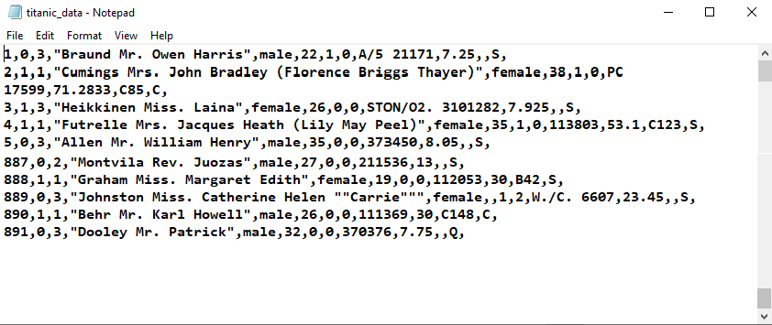

**Output:**

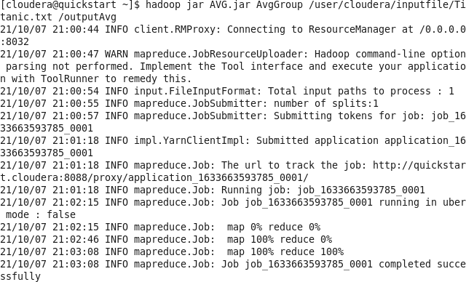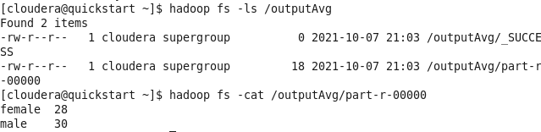

hadoop fs jar AVG.jar AvgGroup /user/cloudera/inputfile/Titanic.txt /outputAvg

hadoop fs -cat /outputAvg/part-r-00000

**Aim:** Write a program in Map Reduce for Matrix Multiplication

### Code:

import java.io.IOException; import java.util.*;

import org.apache.hadoop.fs.Path; import org.apache.hadoop.conf.*; import org.apache.hadoop.io.*;

import org.apache.hadoop.mapreduce.*;

import org.apache.hadoop.mapreduce.Reducer.Context;

import org.apache.hadoop.mapreduce.lib.input.FileInputFormat; import org.apache.hadoop.mapreduce.lib.input.TextInputFormat; import org.apache.hadoop.mapreduce.lib.output.FileOutputFormat; import org.apache.hadoop.mapreduce.lib.output.TextOutputFormat;

public class Matrix {

public static class MapM extends Mapper<LongWritable, Text, Text, Text> {

public void map(LongWritable key, Text value, Context context) throws IOException, InterruptedException{

Configuration conf = context.getConfiguration(); int m = Integer.parseInt(conf.get("m"));

int p = Integer.parseInt(conf.get("p"));

String line = value.toString();

String[] indicesAndValue = line.split(","); Text outputKey = new Text();

Text outputValue = new Text();

if(indicesAndValue[0].equals("M")){ for(int k = 0 ; k< p ; k++)

{

outputKey.set(indicesAndValue[1] + "," + k); outputValue.set(indicesAndValue[0] + "," + indicesAndValue[2] +

"," + indicesAndValue[3] );

context.write(outputKey, outputValue);

}

else

{

}

for(int i=0 ; i<m; i++)

{

indicesAndValue[3]);

}

}

}

}

outputKey.set(i + "," + indicesAndValue[2]); outputValue.set("N," + indicesAndValue[1] + "," +

context.write(outputKey, outputValue);

public static class ReduceM extends Reducer<Text, Text, Text, Text> {

public void reduce(Text key, Iterable<Text> values, Context context) throws IOException, InterruptedException {

String[] value;

HashMap<Integer, Float> hashA = new HashMap<Integer, Float>(); HashMap<Integer, Float> hashB = new HashMap<Integer, Float>();

for(Text val : values){

value =val.toString().split(",");

if(value[0].equals("M"))

{

}

else

{

}

hashA.put(Integer.parseInt(value[1]), Float.parseFloat(value[2]));

hashB.put(Integer.parseInt(value[1]), Float.parseFloat(value[2]));

}

int n = Integer.parseInt(context.getConfiguration().get("n")); float result = 0.0f;

float m_ij; float n_jk;

for(int j=0; j<n; j++){

m_ij = hashA.containsKey(j) ? hashA.get(j) : 0.0f; n_jk = hashB.containsKey(j) ? hashB.get(j) : 0.0f;

result += m_ij * n_jk;

}

if(result != 0.0f){

context.write(null, new Text( key.toString() + " " + Float.toString(result)));

}

}

}

public static void main(String[] args) throws Exception{ if(args.length != 2){

System.err.println("use 2 arguments"); System.exit(2);

}

Configuration conf = new Configuration(); conf.set("m", "2");

conf.set("n", "3");

conf.set("p", "2"); @SuppressWarnings("depcretion")

Job job = new Job(conf,"Matrix"); job.setJarByClass(Matrix.class); job.setOutputKeyClass(Text.class); job.setOutputValueClass(Text.class);

job.setMapperClass(MapM.class); job.setReducerClass(ReduceM.class);

job.setInputFormatClass(TextInputFormat.class); job.setOutputFormatClass(TextOutputFormat.class);

FileInputFormat.addInputPath(job, new Path(args[0])); FileOutputFormat.setOutputPath(job, new Path(args[1])); job.waitForCompletion(true);

}

}

### Input File:

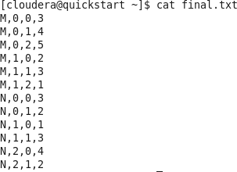

**Output:**

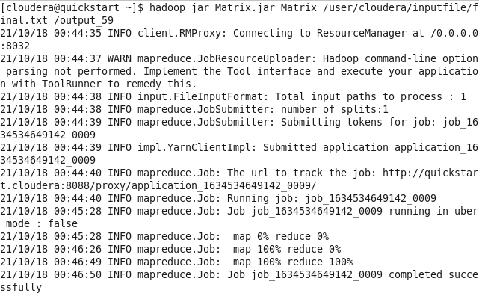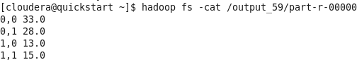

hadoop jar Matrix.jar Matrix /user/cloudera/inputfile/final.txt /output_59

hadoop fs -cat /output_59/part-r-00000

# Practical No 3

MongoDB

#### Installation

1. **Sample Database Creation**

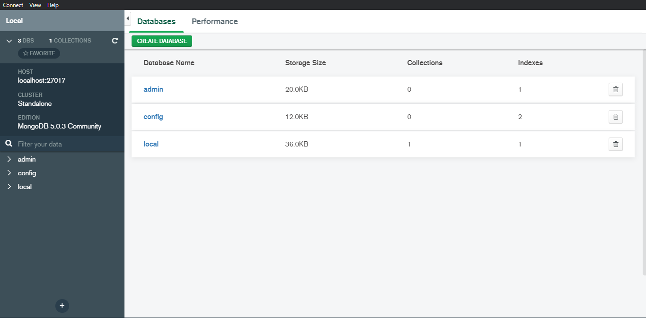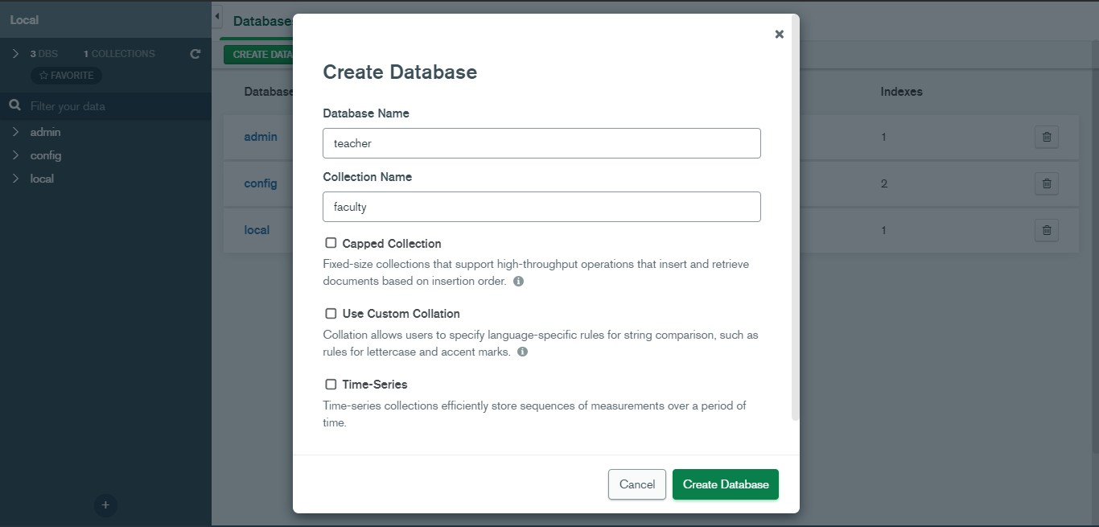

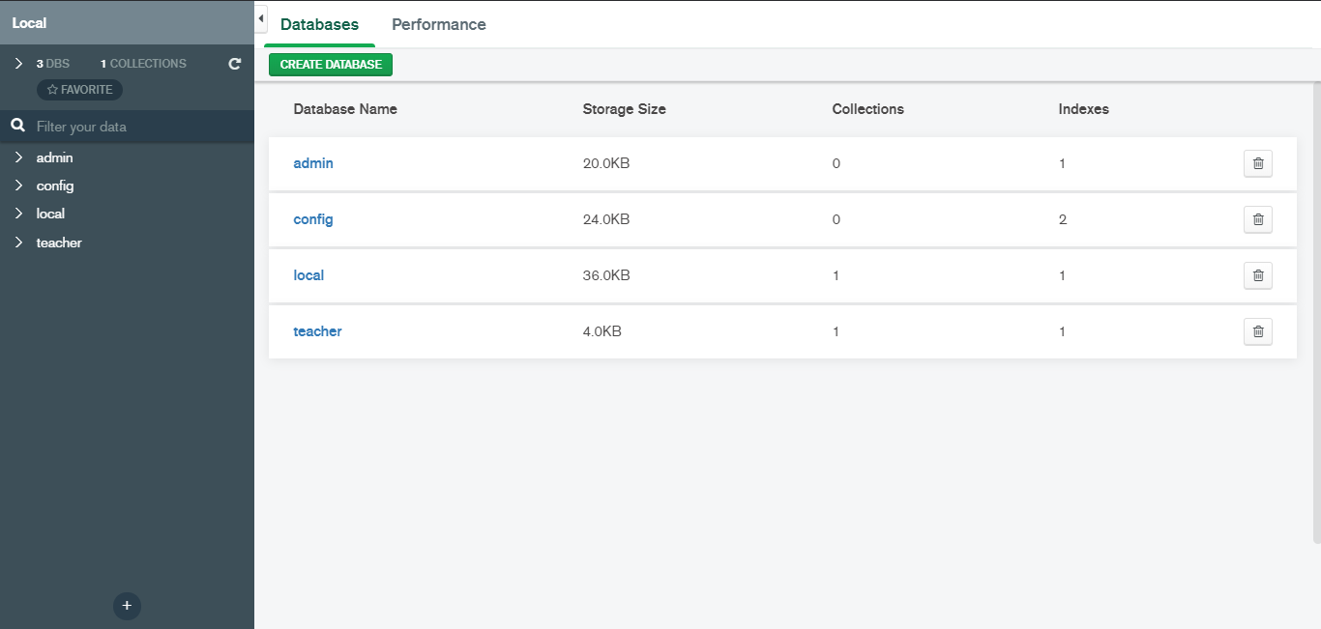

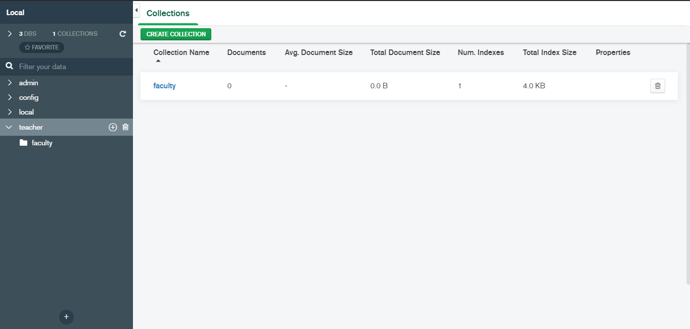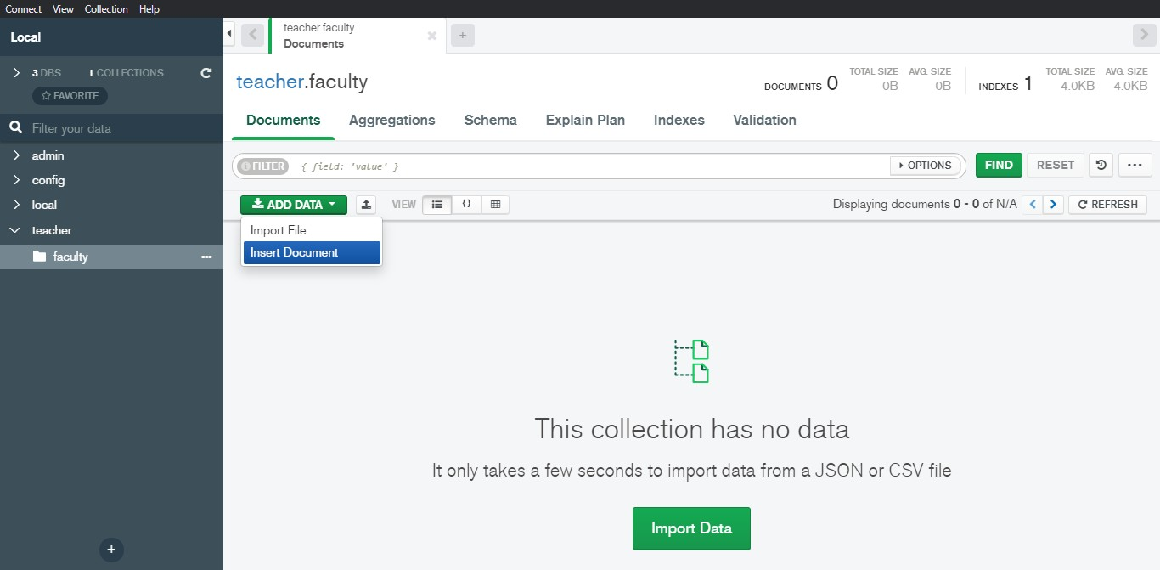

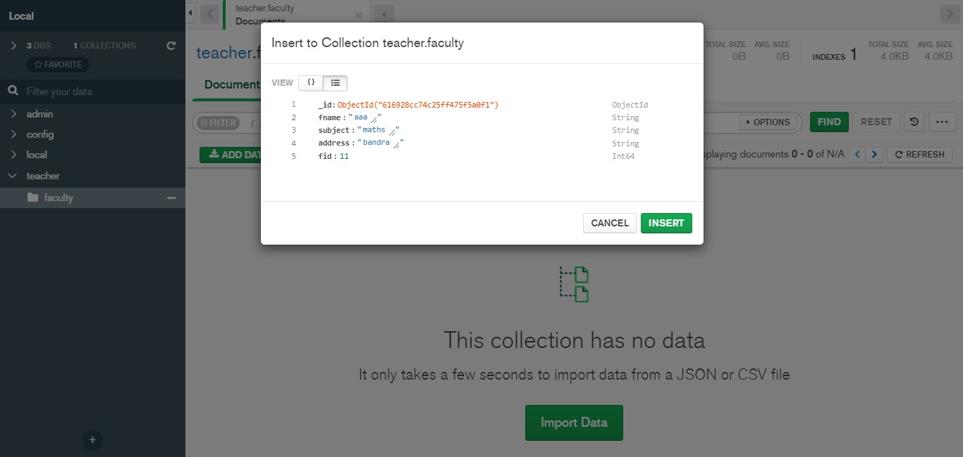

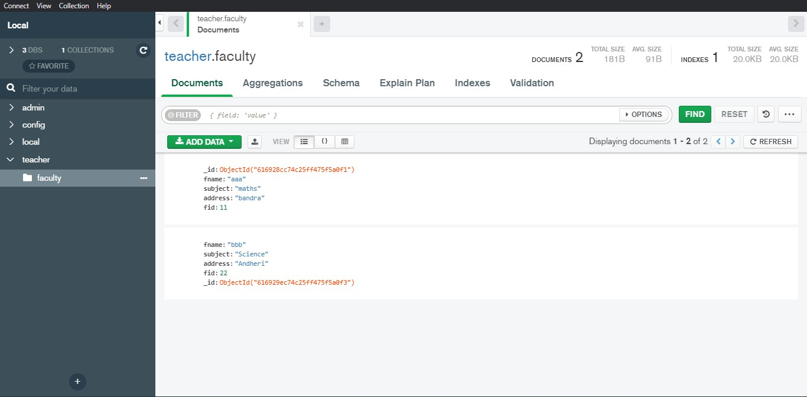

1. **Query the Sample Database using MongoDB querying commands**
   1. **Create Collection**

In MongoDB, db.createCollection(name, options) is used to create collection. But usually you don’t need to create collection. MongoDB creates collection automatically when you insert some documents.

### Syntax:

db.createCollection(**name**, options)

### Example:

show dbs





use teacher

show collections

db.faculty.find()

db.createCollection("book")

show collections

* 1. **Insert Document**

In MongoDB, the **db.collection.insert()** method is used to add or insert new documents into a collection in your database.

**Syntax:** db.COLLECTION_NAME.**insert**(document)

### Example:



db.book.insert({"b_id":33, "b_language":"English", "author":"xyz", "edition":"first"})

db.book.find()

db.book.insert({"b_id":11, "b_language":"Marathi", "author":"abc", "edition":"first"})

db.book.insert({"b_id":22, "b_language":"Hindi", "author":"pqr", "edition":"second"})

db.book.find()

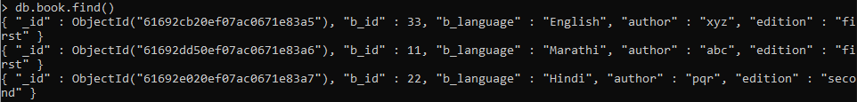

* 1. **Query Document**

In MongoDB, the **db.collection.find()** method is used to retrieve documents from a collection. This method returns a cursor to the retrieved documents.

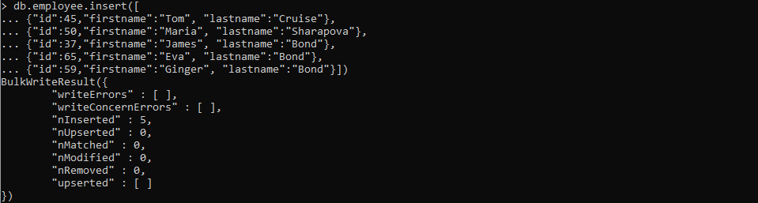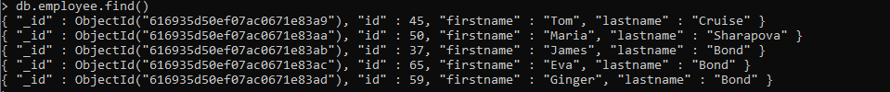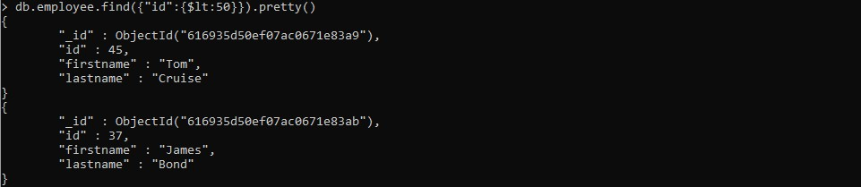

db.employee.insert([

{"id":45,"firstname":"Tom", "lastname":"Cruise"},

{"id":50,"firstname":"Maria", "lastname":"Sharapova"},

{"id":37,"firstname":"James", "lastname":"Bond"},

{"id":65,"firstname":"Eva", "lastname":"Bond"},

{"id":59,"firstname":"Ginger", "lastname":"Bond"}])

db.employee.find()

db.employee.find({"id":{$lt:50}}).pretty()

db.employee.find({"id":{$gt:50}}).pretty()

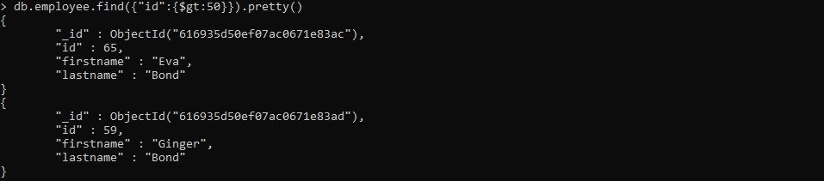

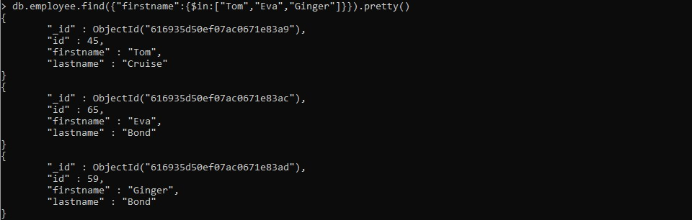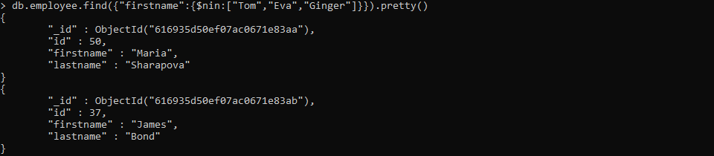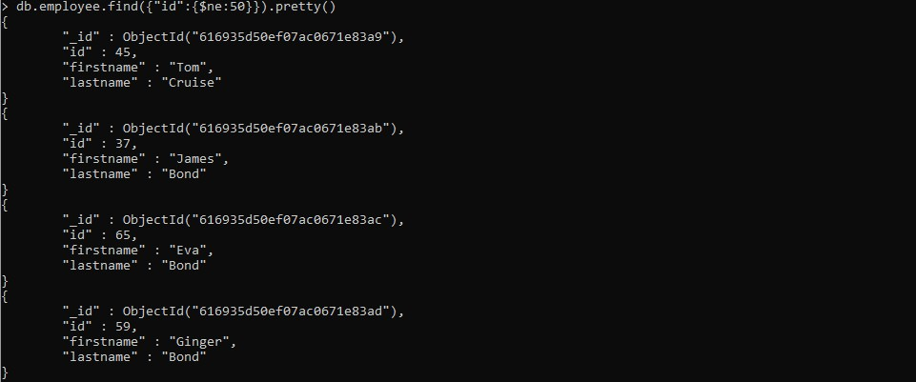

db.employee.find({"firstname":{$in:["Tom","Eva","Ginger"]}}).pretty()

db.employee.find({"firstname":{$nin:["Tom","Eva","Ginger"]}}).pretty()

db.employee.find({"id":{$ne:50}}).pretty()

db.employee.find()

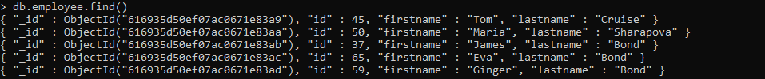

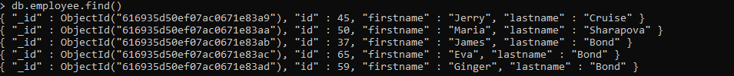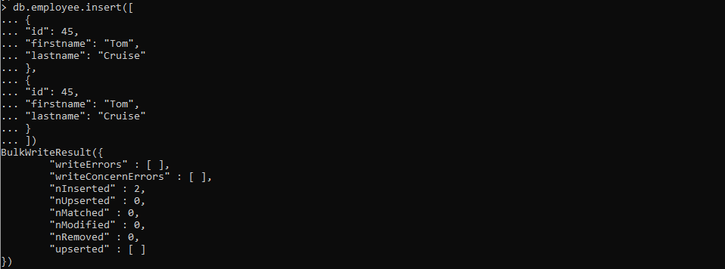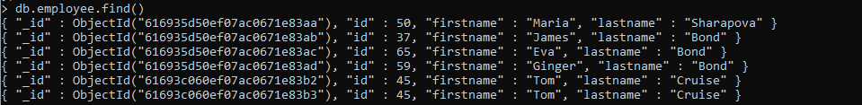

db.employee.update({"firstname": "Tom"},{$set:{"firstname": "Jerry"}})

db.employee.find()

db.employee.insert([

{"id": 45, "firstname": "Tom","lastname": "Cruise"},

{"id": 45,"firstname": "Tom","lastname": "Cruise"}

])

db.employee.find()

### Delete Document

In MongoDB, the db.colloction.remove() method is used to delete documents from a collection. The remove() method works on two parameters.

**Syntax:** db.collection_name.remove (DELETION_CRITERIA)

show dbs



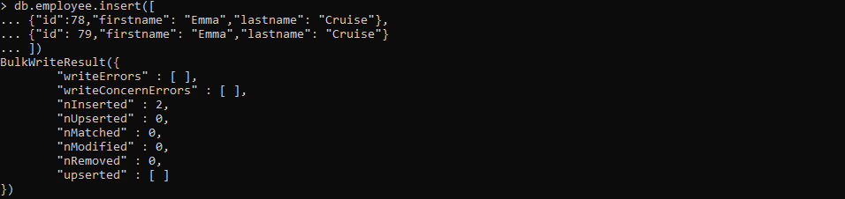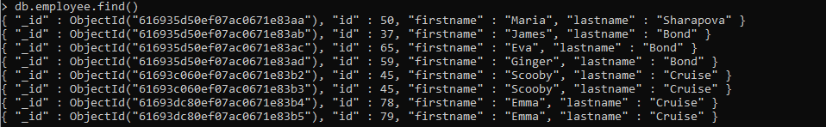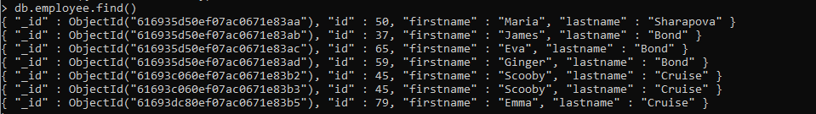

use student

db.dropDatabase()

show dbs

db.employee.insert([

{"id":78,"firstname": "Emma","lastname": "Cruise"},

{"id": 79,"firstname": "Emma","lastname": "Cruise"}

])

db.employee.find()

db.employee.remove({"id":78})

db.employee.find()

#### Indexing

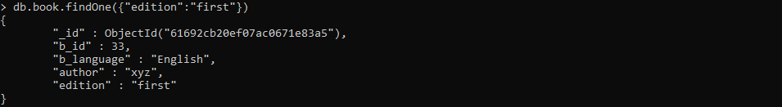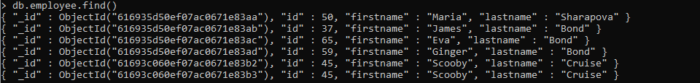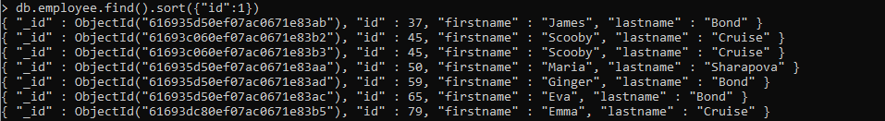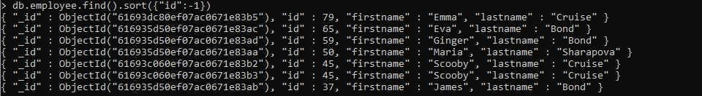

db.book.findOne({"edition":"first"})

show collections

db.library.insert({"library_id":56, "lib_name":"hiray", "lib_address":"bandra"})

show collections

db.employee.update({"firstname":"Tom"},{$set:{"firstname": "Scooby"}},{multi:true})

db.employee.find()

db.employee.find().sort({"id":1})

db.employee.find().sort({"id":-1})

db.employee.drop()

db.employee.insert([

{

"userId":"rirani", "jobTitleName":"Developer", "firstName":"Romin","lastName":"Irani", "preferredFullName":"Romin Irani","employeeCode":"E1","region":"CA", "phoneNumber":"408-1234567","emailAddress":["r](mailto:romin.k.irani@gmail.com)o[min.k.irani@gmail.com](mailto:romin.k.irani@gmail.com)","age":42

},

{

"userId":"nirani","jobTitleName":"Developer","firstName":"Neil","lastName":"Irani", "preferredFullName":"Neil Irani","employeeCode":"E2","region":"CA", "phoneNumber":"408-1111111","emailAddress":["neilrirani@](mailto:neilrirani@gmail.com)g[mail.com](mailto:neilrirani@gmail.com)","age":36

},

{

"userId":"thanks","jobTitleName":"Program Directory","firstName":"Tom","lastName":"Hanks", "preferredFullName":"Tom Hanks","employeeCode":"E3","region":"CA",

"phoneNumber":"408-2222222","emailAddress":"[tomhanks@gmail.com](mailto:tomhanks@gmail.com)","age":34

},

{

"userId":"rirani","jobTitleName":"Developer","firstName":"Romin","lastName":"Irani", "preferredFullName":"Romin Irani","employeeCode":"E1","region":"CB", "phoneNumber":"408-1234567","emailAddress":["r](mailto:romin.k.irani@gmail.com)o[min.k.irani@gmail.com](mailto:romin.k.irani@gmail.com)","age":45

},

{

"userId":"nirani","jobTitleName":"Developer","firstName":"Neil","lastName":"Irani", "preferredFullName":"Neil Irani","employeeCode":"E2","region":"CB", "phoneNumber":"408-1111111","emailAddress":["neilrirani@](mailto:neilrirani@gmail.com)g[mail.com](mailto:neilrirani@gmail.com)","age":32

},

{

"userId":"thanks","jobTitleName":"Program Directory","firstName":"Tom","lastName":"Hanks", "preferredFullName":"Tom Hanks","employeeCode":"E3","region":"CB",

"phoneNumber":"408-2222222","emailAddress":"[tomhanks@gmail.com](mailto:tomhanks@gmail.com)","age":36

}])

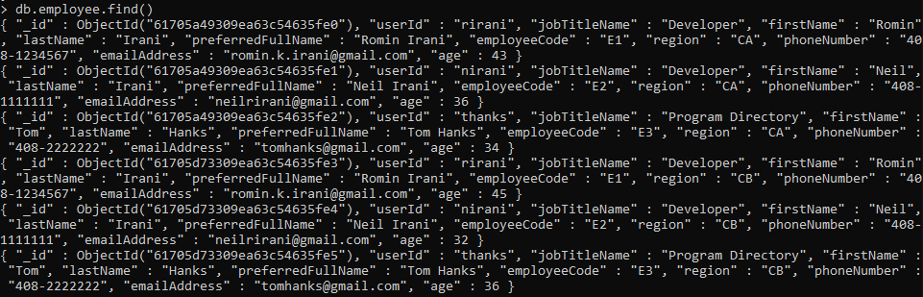

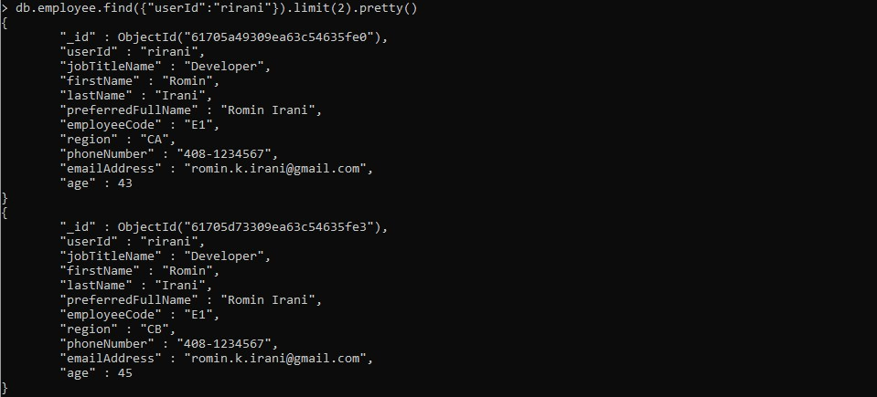

db.employee.aggregate([{$group{_id:"$region",age_s:{$sum:"$age"}}}])

db.employee.find({"userId":"rirani"}).limit(2)

# Practical No. 4 Hive

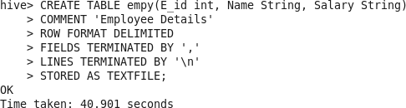

CREATE TABLE empy(eid int, name String, Salary String) COMMENT 'Employee Details'

ROW FORMAT DELIMITED FIELDS TERMINATED BY ',' LINES TERMINATED BY '\n'

STORED AS TEXTFILE;

### Input File:

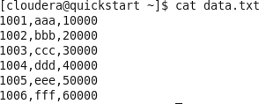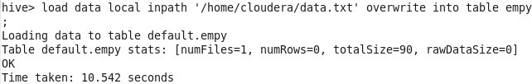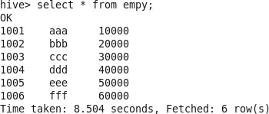

load data local inpath '/home/cloudera/data.txt' overwrite into table empy;

Select * from empy;

Alter table empy rename to Employee;

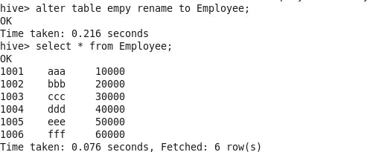

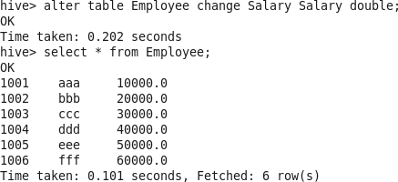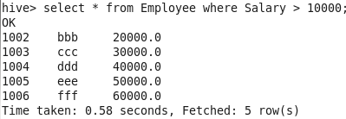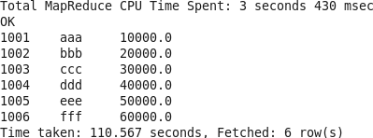

Alter table Employee change Salary Salary double;

Select * from Employee where Salary > 10000;

Select * from Employee order by Salary;

Select Salary, count(*) from Employee group by Salary;

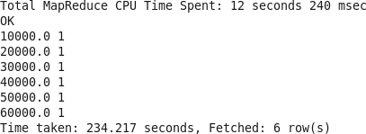

**Input File:**

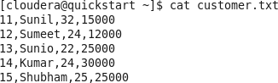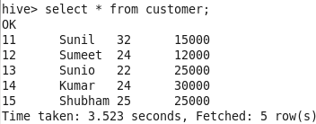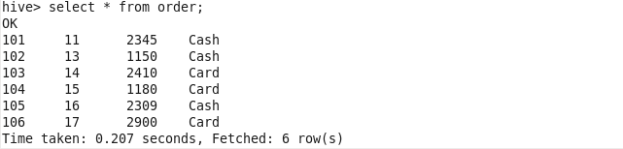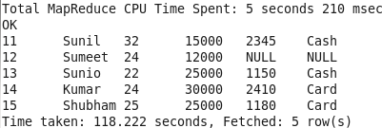

Select * from customer;

Select * from order;

Select c.cust_id, c.cust_name, c.age, c.salary, o.amount, o.payment from customer c LEFT OUTER JOIN order o on(c.cust_id=o.customer_id);

Select c.cust_id, c.cust_name, c.age, c.salary, o.amount, o.payment from customer c RIGHT OUTER JOIN order o on(c.cust_id=o.customer_id);

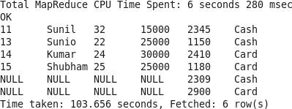

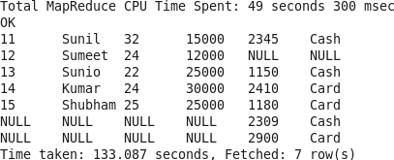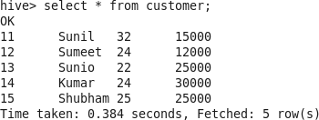

Select c.cust_id, c.cust_name, c.age, c.salary, o.amount, o.payment from customer c FULL OUTER JOIN order o on(c.cust_id=o.customer_id);

Select * from customer;

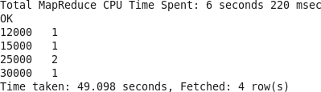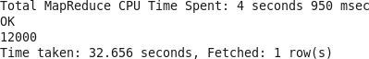

Select salary, count(*) from customer group by salary;

Select min(salary) from customer;

Select avg(salary) from customer;

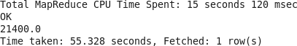

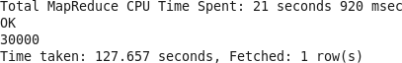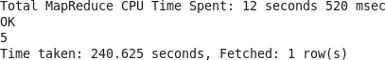

Select max(salary) from customer;

Select count(*) from customer;

# Practical No. 5 Pig

### Input File:

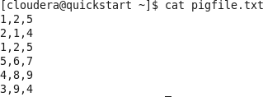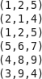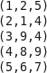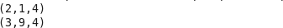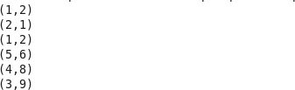

data = LOAD '/user/cloudera/piginput/pigfile.txt' USING PigStorage (',') AS (A1:int, A2:int, A3:int);

dump data;

result = DISTINCT data;

dump result;

fltresult= FILTER data BY A3==4;

dump fltresult;

feresult= FOREACH data generate A1,A2;

dump feresult;

**Input File:**

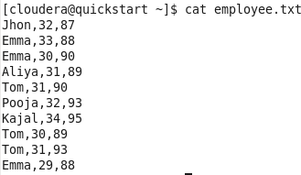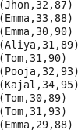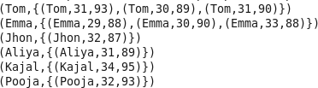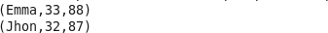

student = LOAD '/user/cloudera/piginput/employee.txt' USING PigStorage(',') AS (name:charArray, Age:int, Grade:int);

dump student;

grpname= GROUP student BY name;

dump grpname;

lmtresult = LIMIT student 2;

dump lmtresult;

ascresult = ORDER student BY name;

dump ascresult;

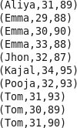

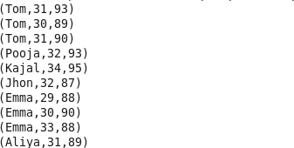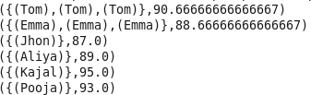

descresult = ORDER student BY name DESC;

dump descresult;

groupname = GROUP student BY name;

avgres= FOREACH groupname generate student.name, AVG(student.Grade); dump avgres;

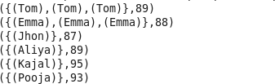

groupname = GROUP student BY name;

minres= FOREACH groupname generate student.name, MIN(student.Grade); dump minres;

groupname = GROUP student BY name;

maxres= FOREACH groupname generate student.name, MAX(student.Grade);

dump maxres;

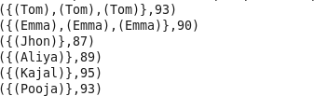

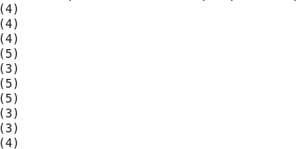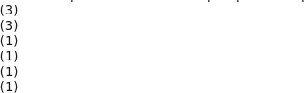

sizeres = FOREACH student generate SIZE(name);

dump sizeres;

groupname = GROUP student BY name;

countres= FOREACH groupname generate COUNT(student); dump countres;

### Input File:

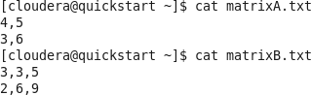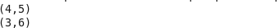

matrixA= LOAD '/user/cloudera/piginput/matrixA.txt' USING PigStorage(',') AS(a1:int, a2:int);

dump matrixA

matrixB= LOAD '/user/cloudera/piginput/matrixB.txt' USING PigStorage(',') AS(a1:int, a2:int, a3:int);

dump matrixB



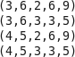

Crossresult= CROSS matrixA,matrixB;

dump crossresult;

**Input File:**

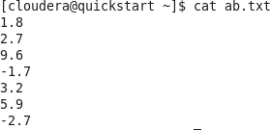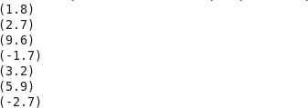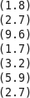

AB = LOAD '/user/cloudera/piginput/ab.txt' AS(ab1:float);

dump AB;

abresult= FOREACH AB GENERATE ABS(ab1);

dump abresult;

### Input File:

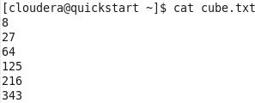

CB = LOAD '/user/cloudera/piginput/cube.txt' AS(c1:int);

dump CB;

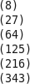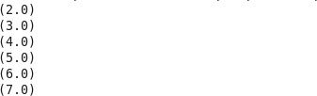

cbresult= FOREACH CB GENERATE CBRT(c1);

dump cbresult;

**Input File:**

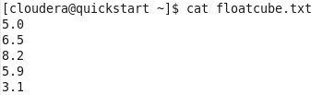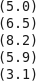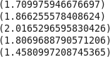

FLCB = LOAD '/user/cloudera/piginput/floatcube.txt' AS(c1:float);

dump FLCB;

flcbresult= FOREACH FLCB GENERATE CBRT(c1);

dump flcbresult;

### Input File:

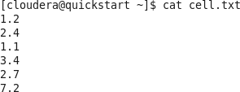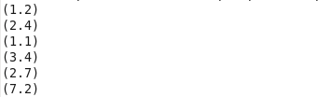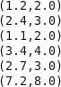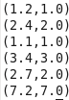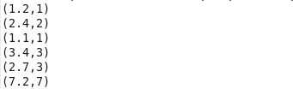

cell = LOAD '/user/cloudera/piginput/cell.txt' AS(ce:float);

dump cell;

cellresult= FOREACH cell GENERATE (ce), CEIL(ce);

dump cellresult;

floorresult= FOREACH cell GENERATE (ce), FLOOR(ce);

dump floorresult;

roundresult= FOREACH cell GENERATE (ce), ROUND(ce);

dump roundresult;

**Input File:**

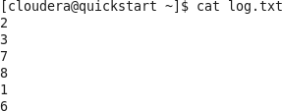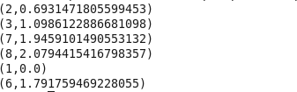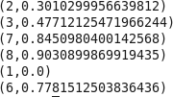

logdata= LOAD '/user/cloudera/piginput/log.txt' AS(l1:int);

dump logdata;

logresult= FOREACH logdata GENERATE (l1), LOG(l1);

dump logresult;

logtresult=FOREACH logdata GENERATE (l1), LOG10(l1);

dump logtresult;

# Practical No. 6 Scala: Spark

var a=10;

a: Int = 10

a;

res0: Int = 10

var b=20;

b: Int = 20

b;

res1: Int = 20

var s="abc";

s: String = abc

s;

res2: String = abc

var c=a+b;

c: Int = 30

c;

res3: Int = 30

val a=Array(1,2,3,4,5,6);

a: Array[Int] = Array(1, 2, 3, 4, 5, 6)

val b=sc.parallelize(a);

b: org.apache.spark.rdd.RDD[Int] = ParallelCollectionRDD[0] at parallelize at <console>:29

b;

res4: org.apache.spark.rdd.RDD[Int] = ParallelCollectionRDD[0] at parallelize at <console>:29

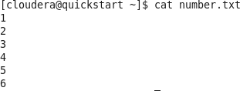

val n1=sc.textFile("file:/home/cloudera/number.txt");

n1: org.apache.spark.rdd.RDD[String] = file:/home/cloudera/number.txt MapPartitionsRDD[2] at textFile at <console>:27

n1;

res5: org.apache.spark.rdd.RDD[String] = file:/home/cloudera/number.txt MapPartitionsRDD[2] at textFile at <console>:27

n1.collect();

res6: Array[String] = Array(1, 2, 3, 4, 5, 6)

n1.count();

res7: Long = 6

n1.first();

res8: String = 1

n1.take(5);

res9: Array[String] = Array(1, 2, 3, 4, 5)

val y=sc.parallelize(List(10,20,30));

y: org.apache.spark.rdd.RDD[Int] = ParallelCollectionRDD[3] at parallelize at <console>:27

y.collect();

res10: Array[Int] = Array(10, 20, 30)

val mapt=y.map(x=>x+5);

mapt: org.apache.spark.rdd.RDD[Int] = MapPartitionsRDD[4] at map at <console>:29

mapt.collect();

res11: Array[Int] = Array(15, 25, 35)

val mapm=y.map(x=>x-10);

mapm: org.apache.spark.rdd.RDD[Int] = MapPartitionsRDD[5] at map at <console>:29

mapm.collect();

res12: Array[Int] = Array(0, 10, 20)

val mapmu=y.map(x=>x*2);

mapmu: org.apache.spark.rdd.RDD[Int] = MapPartitionsRDD[6] at map at <console>:29

mapmu.collect();

res13: Array[Int] = Array(20, 40, 60)

val data=sc.parallelize(List(12,30,30,45,56,78,90,78,45));

data: org.apache.spark.rdd.RDD[Int] = ParallelCollectionRDD[7] at parallelize at <console>:27

val dt=data.distinct();

dt: org.apache.spark.rdd.RDD[Int] = MapPartitionsRDD[10] at distinct at <console>:29

dt.collect();

res14: Array[Int] = Array(56, 12, 45, 30, 90, 78)

val data1=sc.parallelize(List(11,56,76,34,91,24));

data1: org.apache.spark.rdd.RDD[Int] = ParallelCollectionRDD[11] at parallelize at <console>:27

val undata=data.union(data1);

undata: org.apache.spark.rdd.RDD[Int] = UnionRDD[12] at union at <console>:31

undata.collect();

res15: Array[Int] = Array(12, 30, 30, 45, 56, 78, 90, 78, 45, 11, 56, 76, 34, 91, 24)

val interdata=data.intersection(data1);

interdata: org.apache.spark.rdd.RDD[Int] = MapPartitionsRDD[18] at intersection at <console>:31

interdata.collect();

res16: Array[Int] = Array(56)

val cartdata=data.cartesian(data1);

cartdata: org.apache.spark.rdd.RDD[(Int, Int)] = CartesianRDD[19] at cartesian at <console>:31

cartdata.collect();

res17: Array[(Int, Int)] = Array((12,11), (30,11), (12,56), (12,76), (30,56), (30,76), (12,34), (30,34),

(12,91), (12,24), (30,91), (30,24), (30,11), (45,11), (30,56), (30,76), (45,56), (45,76), (30,34), (45,34),

(30,91), (30,24), (45,91), (45,24), (56,11), (78,11), (56,56), (56,76), (78,56), (78,76), (56,34), (78,34),

(56,91), (56,24), (78,91), (78,24), (90,11), (78,11), (45,11), (90,56), (90,76), (78,56), (78,76), (45,56),

(45,76), (90,34), (78,34), (45,34), (90,91), (90,24), (78,91), (78,24), (45,91), (45,24))

val sdata=sc.parallelize(Seq(("z",38),("a",45),("j",30),("c",23),("k",65)));

sdata: org.apache.spark.rdd.RDD[(String, Int)] = ParallelCollectionRDD[20] at parallelize at

<console>:27

sdata.collect();

res18: Array[(String, Int)] = Array((z,38), (a,45), (j,30), (c,23), (k,65))

val sortdata=sdata.sortByKey();

sortdata: org.apache.spark.rdd.RDD[(String, Int)] = ShuffledRDD[23] at sortByKey at <console>:29

sortdata.collect();

res19: Array[(String, Int)] = Array((a,45), (c,23), (j,30), (k,65), (z,38))

val sortdata=sdata.sortByKey(false);

sortdata: org.apache.spark.rdd.RDD[(String, Int)] = ShuffledRDD[26] at sortByKey at <console>:29

sortdata.collect();

res20: Array[(String, Int)] = Array((z,38), (k,65), (j,30), (c,23), (a,45))

val grpdata=sdata.groupByKey();

grpdata: org.apache.spark.rdd.RDD[(String, Iterable[Int])] = ShuffledRDD[27] at groupByKey at

<console>:29

grpdata.collect();

res21: Array[(String, Iterable[Int])] = Array((a,CompactBuffer(45)), (z,CompactBuffer(38)), (j,CompactBuffer(30)), (k,CompactBuffer(65)), (c,CompactBuffer(23)))

val gdata=sc.parallelize(Seq(("z",38),("a",45),("j",30),("c",23),("k",65),("a",54),("j",20),("c",30)));

gdata: org.apache.spark.rdd.RDD[(String, Int)] = ParallelCollectionRDD[28] at parallelize at

<console>:27

val newgrp=gdata.groupByKey();

newgrp: org.apache.spark.rdd.RDD[(String, Iterable[Int])] = ShuffledRDD[29] at groupByKey at

<console>:29

newgrp.collect();

res22: Array[(String, Iterable[Int])] = Array((a,CompactBuffer(45, 54)), (z,CompactBuffer(38)), (j,CompactBuffer(30, 20)), (k,CompactBuffer(65)), (c,CompactBuffer(23, 30)))

### Input File:



val cfile=sc.textFile("file:/home/cloudera/name.txt");

cfile: org.apache.spark.rdd.RDD[String] = file:/home/cloudera/name.txt MapPartitionsRDD[1] at textFile at <console>:27

cfile.collect();

res0: Array[String] = Array(Sunil Sumeet Sunio Piyush Lekha)

var charfile=cfile.flatMap(line=>line.split(""));

charfile: org.apache.spark.rdd.RDD[String] = MapPartitionsRDD[2] at flatMap at <console>:29

charfile.collect();

res1: Array[String] = Array("", S, u, n, i, l, " ", S, u, m, e, e, t, " ", S, u, n, i, o, " ", P, i, y, u, s, h, " ", L, e, k, h, a)

val fchar=charfile.map(fchar=>(fchar,1));

fchar: org.apache.spark.rdd.RDD[(String, Int)] = MapPartitionsRDD[3] at map at <console>:31

fchar.collect();

res2: Array[(String, Int)] = Array(("",1), (S,1), (u,1), (n,1), (i,1), (l,1), (" ",1), (S,1), (u,1), (m,1), (e,1),

(e,1), (t,1), (" ",1), (S,1), (u,1), (n,1), (i,1), (o,1), (" ",1), (P,1), (i,1), (y,1), (u,1), (s,1), (h,1), (" ",1), (L,1), (e,1), (k,1), (h,1), (a,1))

val finalchar=fchar.reduceByKey(_+_);

finalchar: org.apache.spark.rdd.RDD[(String, Int)] = ShuffledRDD[4] at reduceByKey at <console>:33

finalchar.collect();

res3: Array[(String, Int)] = Array((L,1), (P,1), (t,1), (h,2), (" ",4), ("",1), (n,2), (l,1), (s,1), (e,3), (a,1), (i,3), (k,1), (y,1), (u,4), (o,1), (S,3), (m,1))

val namefile=sc.textFile("file:/home/cloudera/name.txt");

namefile: org.apache.spark.rdd.RDD[String] = file:/home/cloudera/name.txt MapPartitionsRDD[1] at textFile at <console>:27

namefile.collect();

res0: Array[String] = Array(Sunil Sumeet Sunio Piyush Lekha Sunil Lekha Sunio Sumeet Sunil)

val splitdata=namefile.flatMap(line=>line.split(" "));

splitdata: org.apache.spark.rdd.RDD[String] = MapPartitionsRDD[2] at flatMap at <console>:29

splitdata.collect();

res1: Array[String] = Array(Sunil, Sumeet, Sunio, Piyush, Lekha, Sunil, Lekha, Sunio, Sumeet, Sunil)

val cword=splitdata.map(cword=>(cword,1));

cword: org.apache.spark.rdd.RDD[(String, Int)] = MapPartitionsRDD[3] at map at <console>:31

cword.collect();

res2: Array[(String, Int)] = Array((Sunil,1), (Sumeet,1), (Sunio,1), (Piyush,1), (Lekha,1), (Sunil,1), (Lekha,1), (Sunio,1), (Sumeet,1), (Sunil,1))

val result=cword.reduceByKey(_+_);

result: org.apache.spark.rdd.RDD[(String, Int)] = ShuffledRDD[4] at reduceByKey at <console>:33

result.collect();

res3: Array[(String, Int)] = Array((Sunio,2), (Piyush,1), (Sunil,3), (Sumeet,2), (Lekha,2))

# Spark Python Mode

### Word Count

**Input File:**

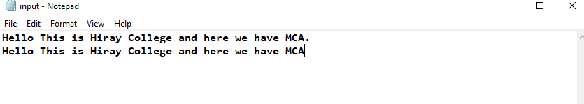

import findspark findspark.init() import pyspark

findspark.find()

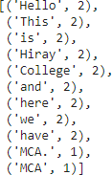

from pyspark import SparkContext, SparkConf sc=SparkContext("local","Counting Words")

nwords=sc.textFile("D:\MCA-SY\BDAnV\Spark-word-count\input.txt").flatMap(lambda line: line.split(" "))

wordCo=nwords.map(lambda nwords:(nwords,1))

wordresult=wordCo.reduceByKey(lambda wordsCount, b: (wordsCount + b)) wordresult.collect()

### KMean

import findspark findspark.init()

findspark.find()

import pyspark

from pyspark.sql import SparkSession

spark = SparkSession.builder.appName("K Means Cluster Model").getOrCreate() spark

from pyspark.ml.clustering import KMeans

from pyspark.ml.feature import VectorAssembler, VectorIndexer from pyspark.ml.feature import StandardScaler

from pyspark.ml.evaluation import ClusteringEvaluator data=spark.read.csv("seeds_dataset.csv", header=True, inferSchema=True)

type(data)

data.head()

data.printSchema()

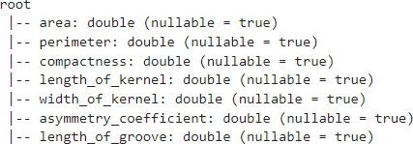

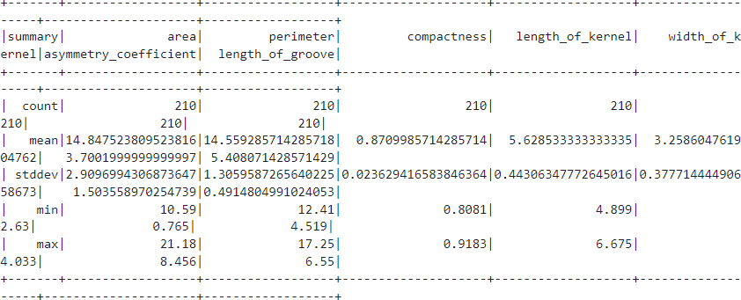

data.describe().show()

#Data Processing assembler=VectorAssembler(inputCols=data.columns,outputCol='features') final_data=assembler.transform(data)

#Scaler scaler=StandardScaler(inputCol='features',outputCol='scaledfeatures') final_data=scaler.fit(final_data).transform(final_data)

final_data.head()

# train and test

train_data,test_data=final_data.randomSplit([0.7,0.3]) train_data.show(2)

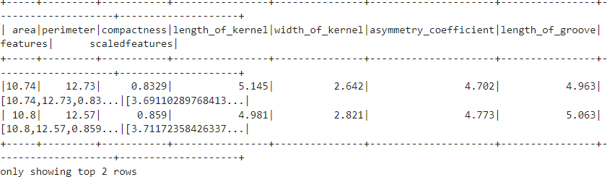

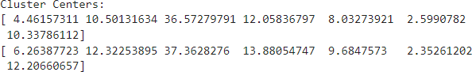

# Build and Evaluate # K-Means

classifier=KMeans(k=2,featuresCol='scaledfeatures') model=classifier.fit(train_data)

# Predictions predictions=model.transform(test_data) #Evaluate clustring by computing Silhoutte score score=ClusteringEvaluator().evaluate(predictions)

print(score)

# Printing clusters centers centers=model.clusterCenters() print("Cluster Centers:")

for center in centers:

print(center)

predictions.show(100)

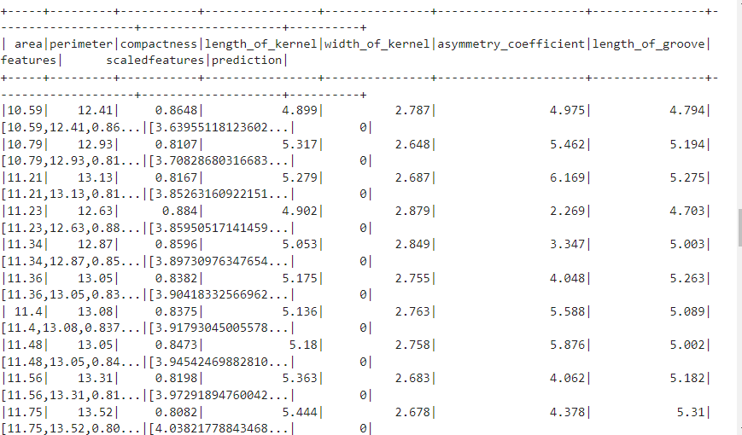

**Page Ranking**

import numpy as np

import matplotlib.pyplot as plt import networkx as nx

# To create an empty graph or initializing a graph G = nx.DiGraph()

# creating pages as nodes pages = ["1","2","3","4"]

G.add_nodes_from(pages) # print nodes of graph

print(G.nodes())

G.add_edges_from([('1','2'),('1','3'),('1','4'),('2','3'),('2','4'),('3','1'),('4','1'),('4','3')])

# printing outward links for each node ['Page 1 = 3'] ['Page 2 = 2'] print("Number of outward links for each node:")

for page in pages:

print(["Page %s = %s" %(page,str(len(G.out_edges(page))))])

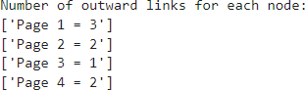

# we will print graph using matplotlib nx.draw(G, with_labels=True)

plt.show()

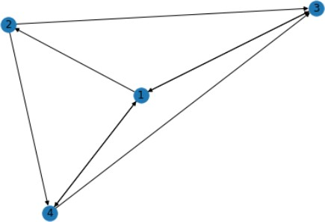



linkmatrix = np.matrix([[0,0,1,1/2],

[1/3,0,0,0],

[1/3,1/2,0,1/2],

[1/3,1/2,0,0]])

def findPageRank(linkmatrix,pages): eigval,eigvector = np.linalg.eig(linkmatrix) final_eigval = np.abs(eigval).max() PageRank = np.where(eigval==final_eigval)

print("The most important page is %s" %(str(pages[PageRank[0][0]])))

findPageRank(linkmatrix,pages)

# Practical No. 7 Tableau

* Open Tableau public and connect to the data source.

JOINS:

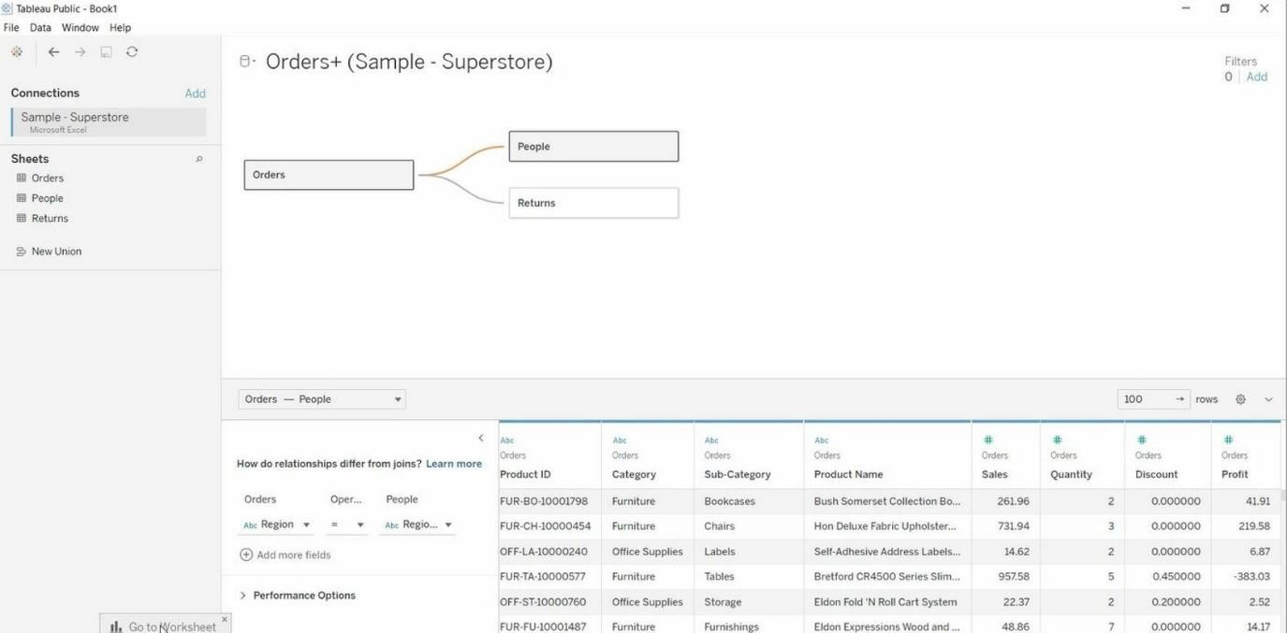

**Bar Graph:**

* Go to the new worksheet.

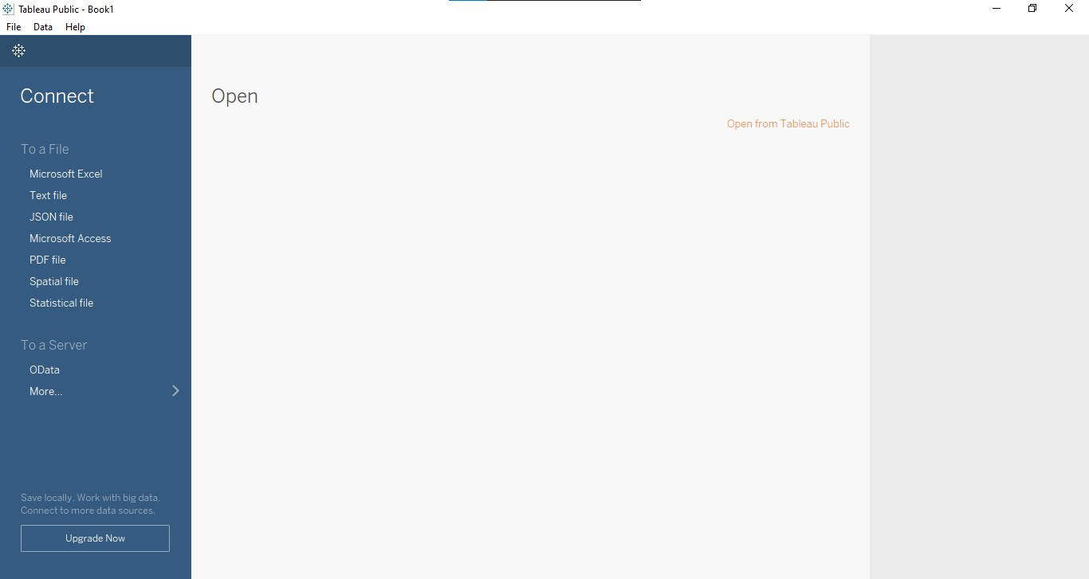

* Under Dimension select Order Date
* Go to the Show Me (user can see chart) ->select chart.
* Go to the Rows > select Year (Order Date) -> drop-down -> select Month.

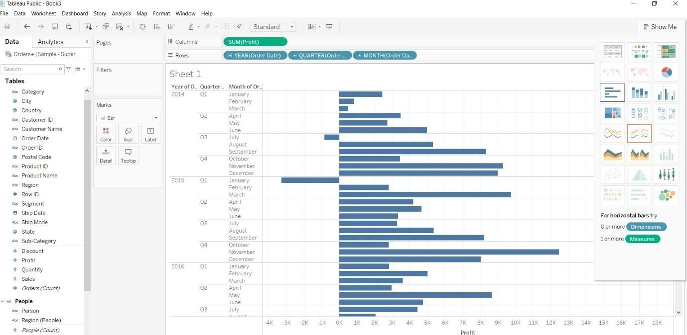

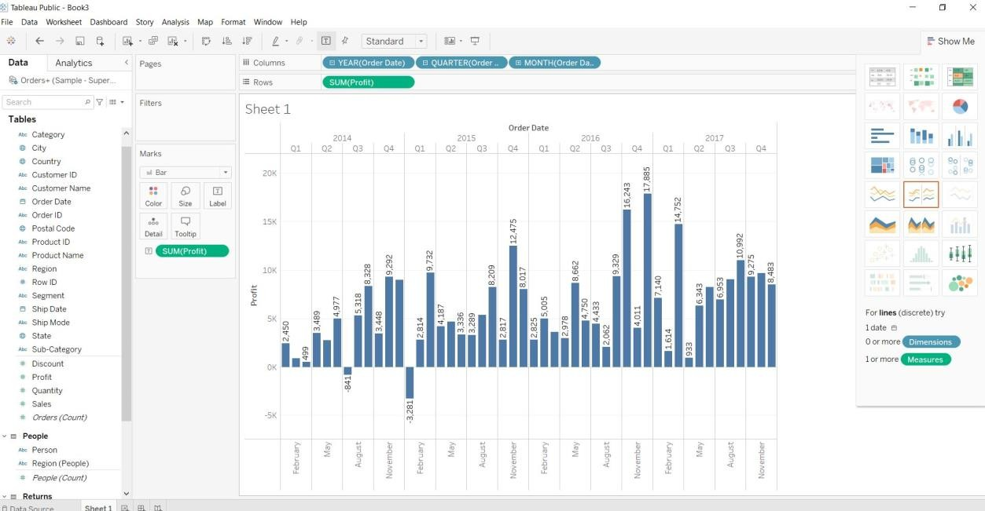Under Dimension select SUM(Profit) ->Drag to Label

**Remove Month & Quarter**

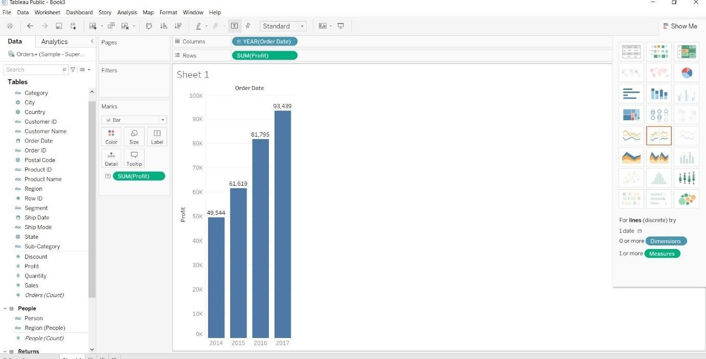

Under Dimension select Year (Order Date) ->Drag to Colour

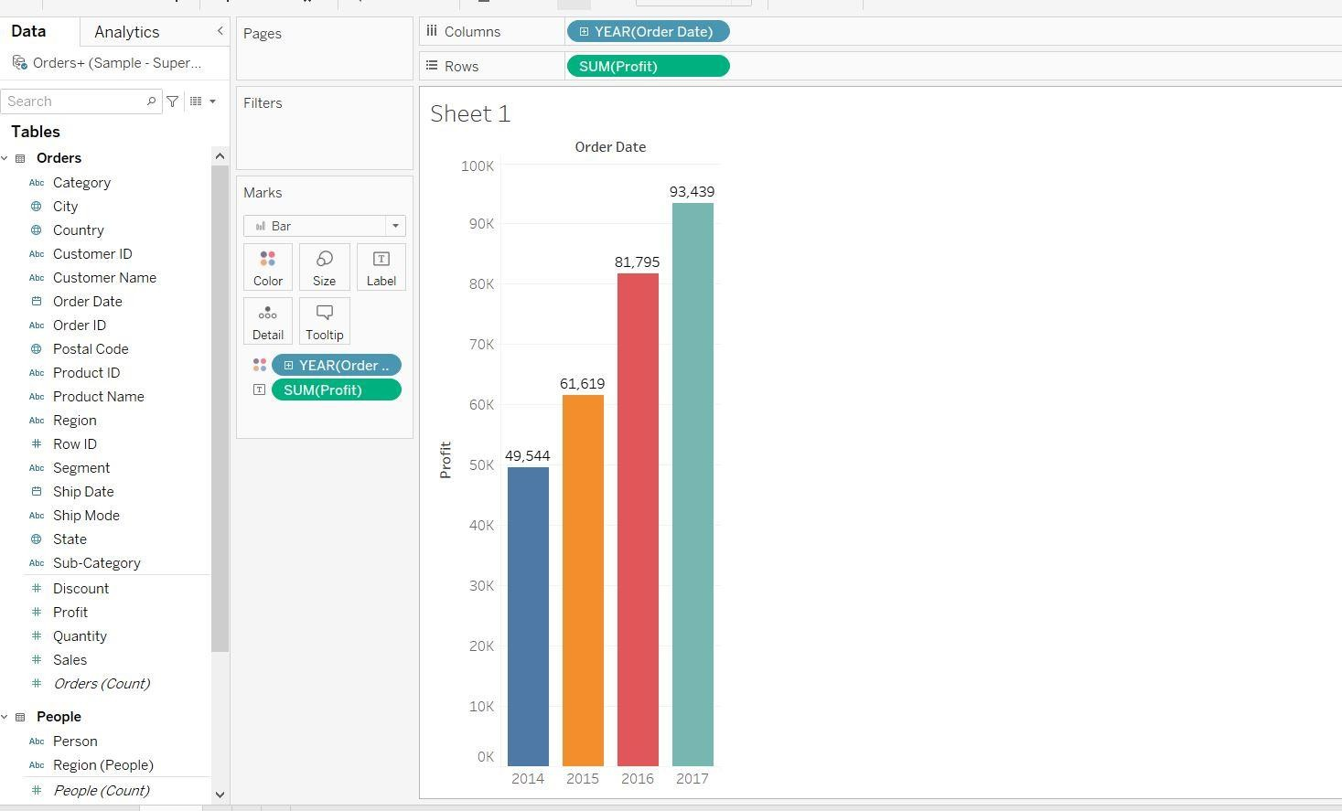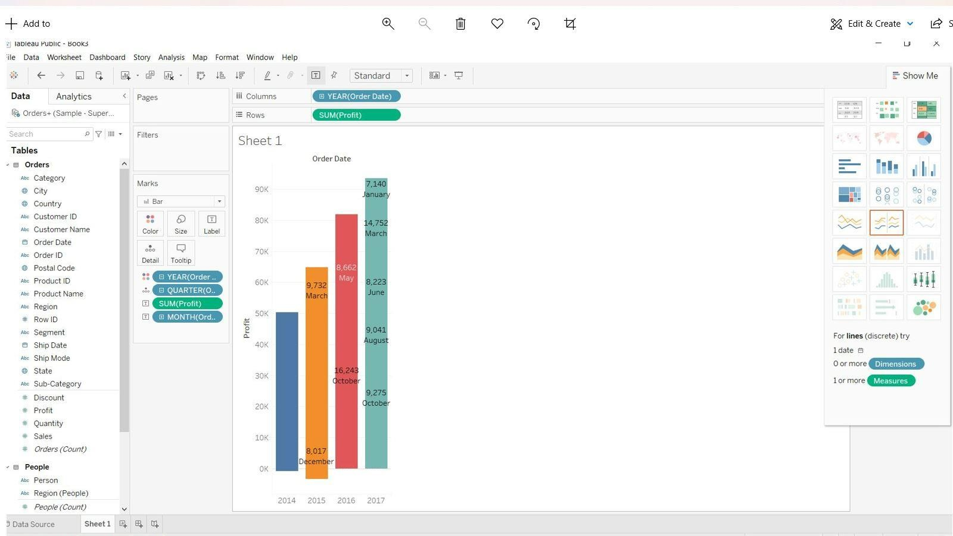

## Multilevel Chart:

* + Open Tableau public and connect to the data source.
  + Go to the new worksheet.
  + Drag **Ship Mode** & **Sales** into rows and **Month** into columns.

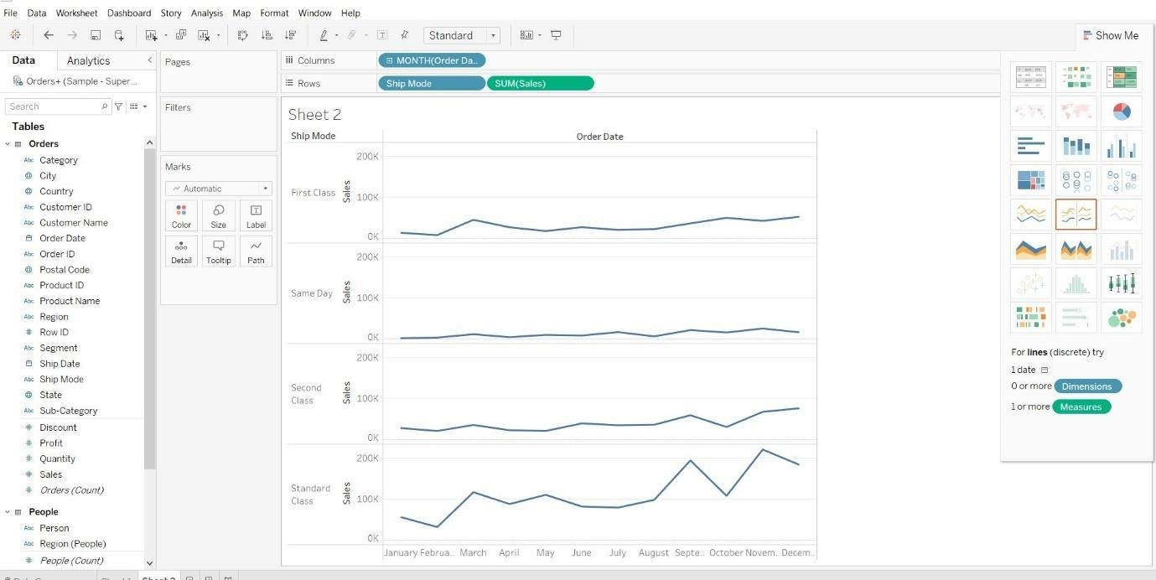

Drag “**Sales**” into Label (Marks card).

Drag “**Ship Mode**” into Colour (Marks card).

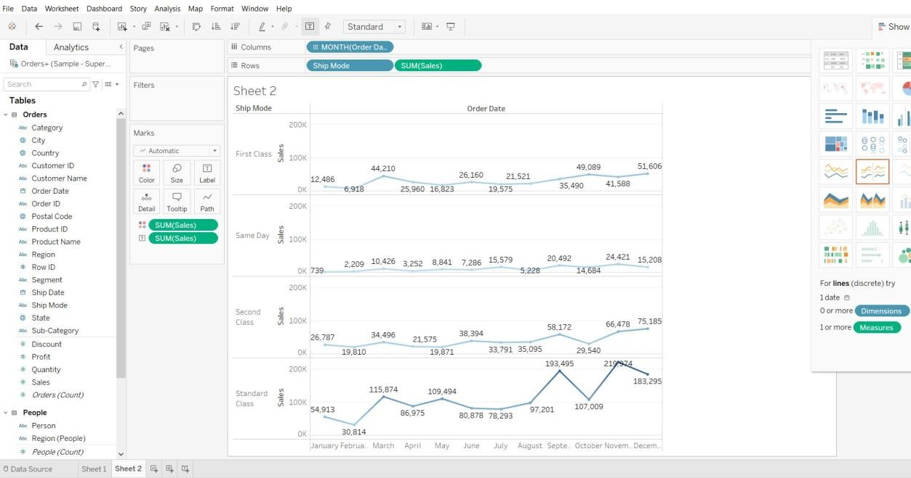

Click on “**show me**”, select chart.

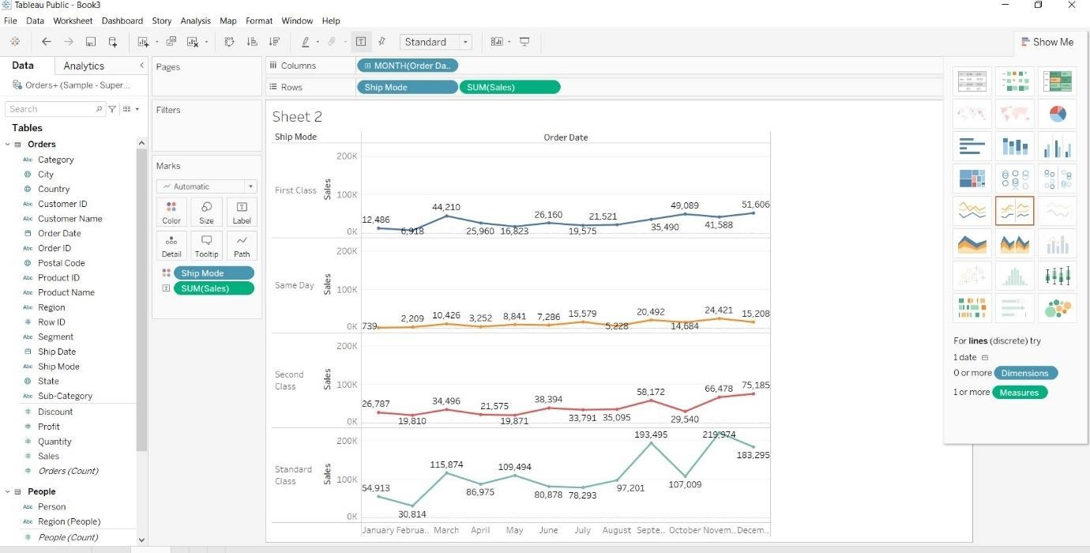

Change Month into Day in Columns

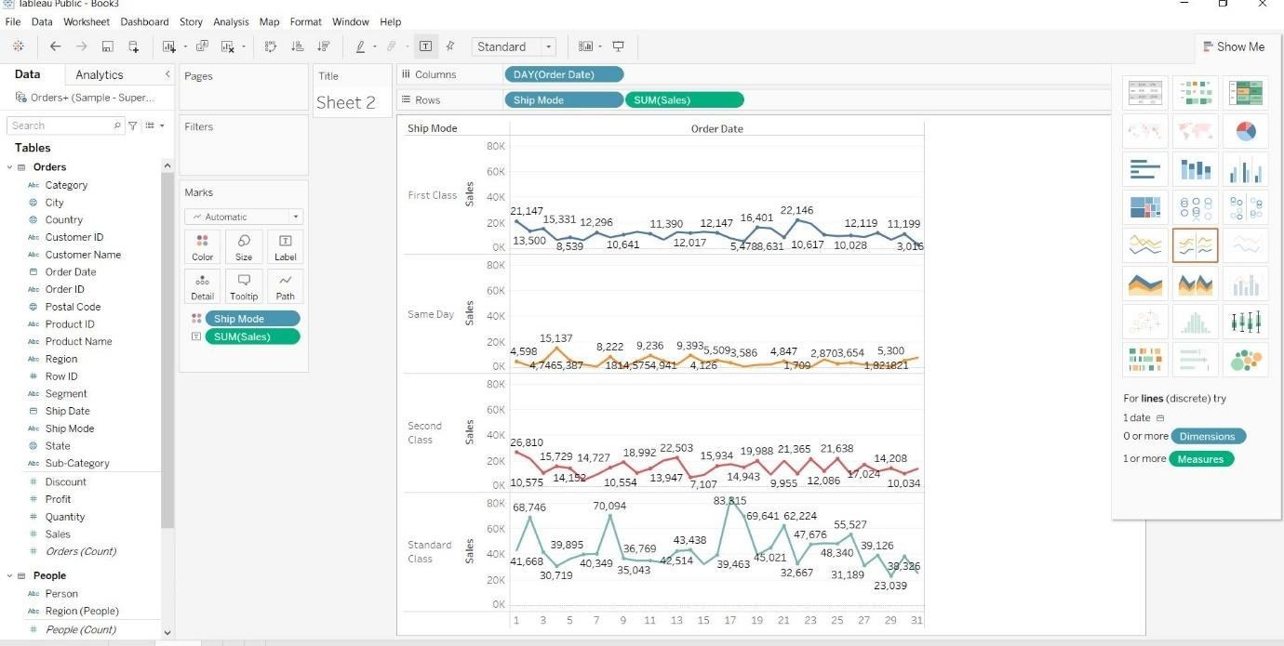

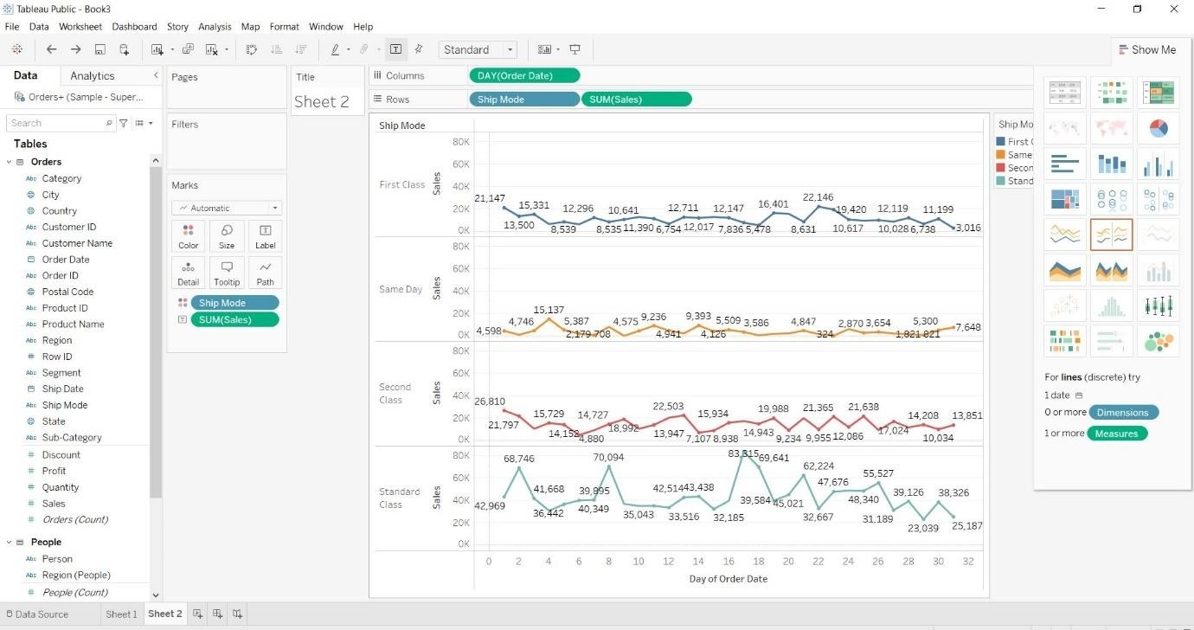

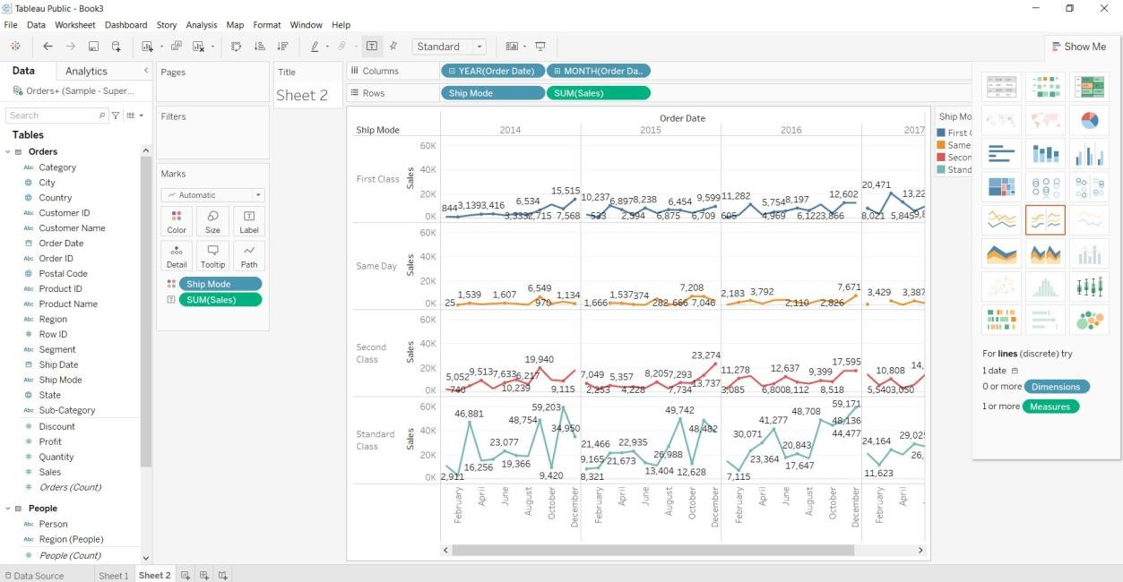

## Mark Plot Chart:

* + Open Tableau public and connect to the data source.
  + Go to the new worksheet.
  + Drag Profit into rows and Sales into columns. This will create a scatter plot by default.

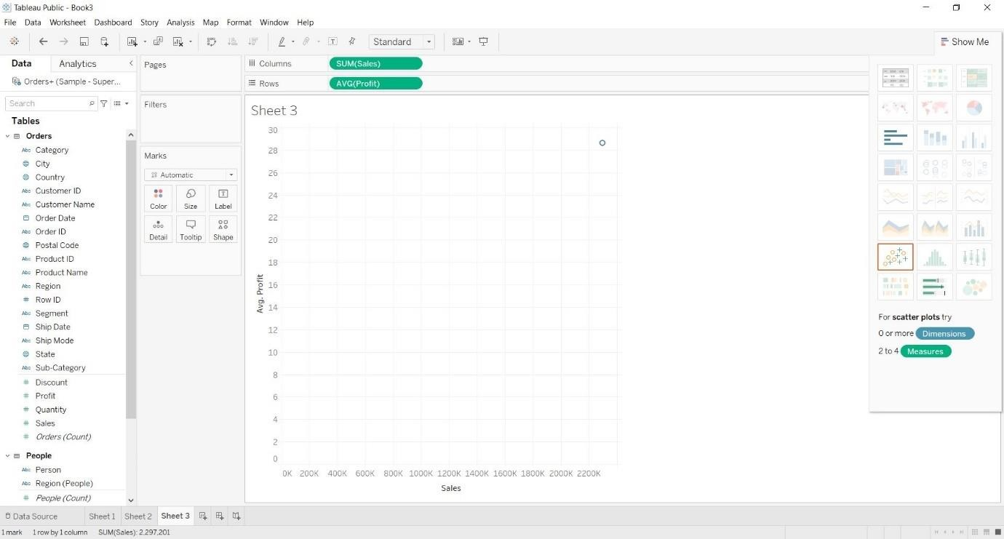

Drag “**Customer Name**” into Detail (Marks card).

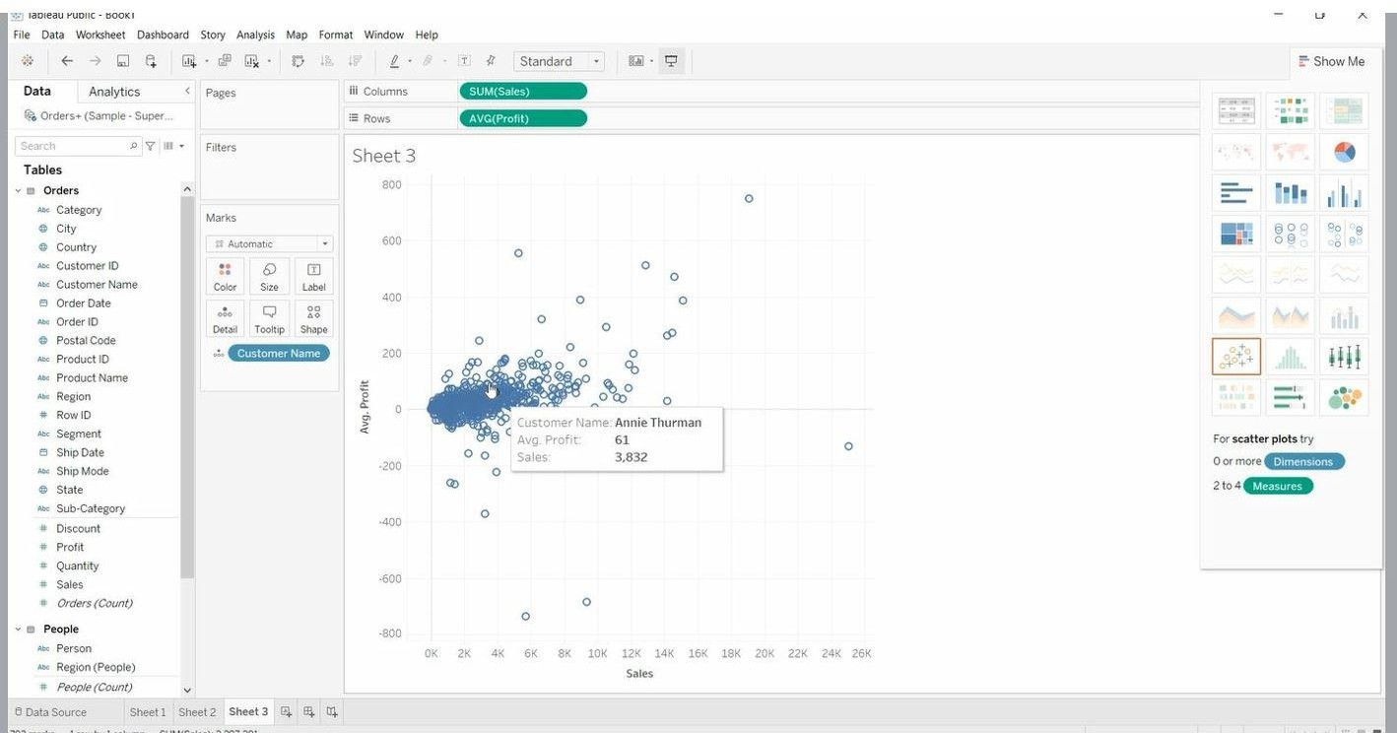

Drag “**AVG(Profit)**” into Label (Marks card).

Right Click on “**AVG(Profit)” > Measure (Average) > Sum**

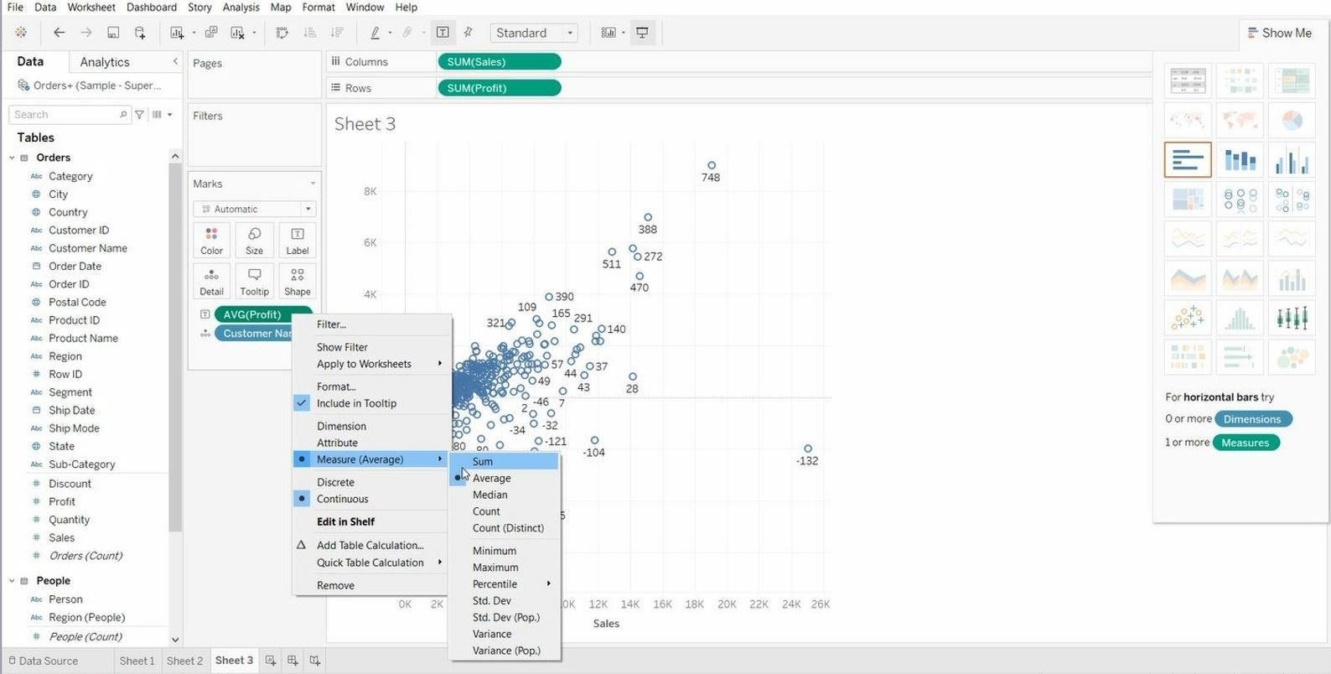

Drag “**Segment**” into Colour (Marks card).

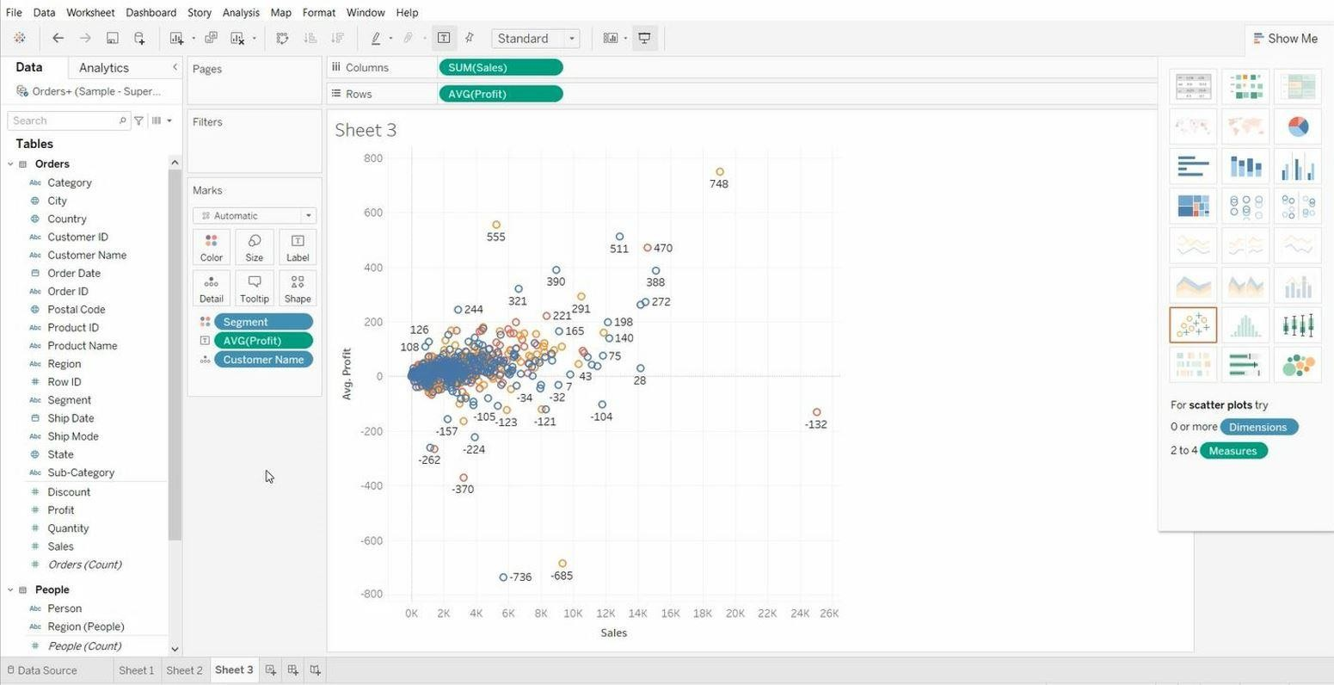

Drag “**Category**” into Shape (Marks card).

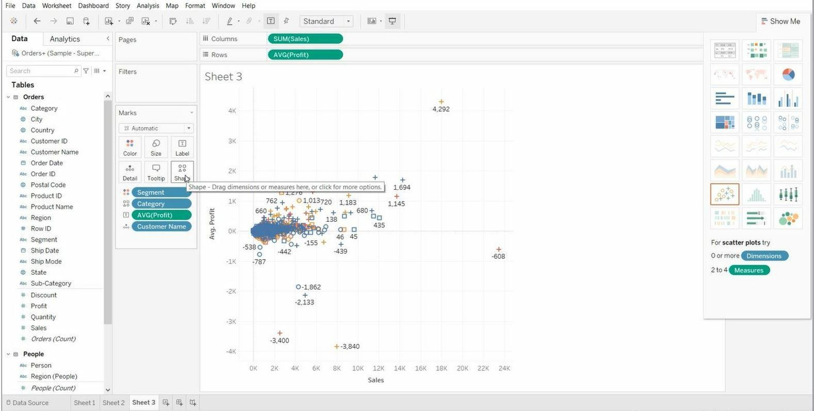

## Working on filters:

* + Open Tableau public and connect to the data source.
  + Go to the new worksheet.
  + Drag **Customer Name** into rows and **Sales** into columns.

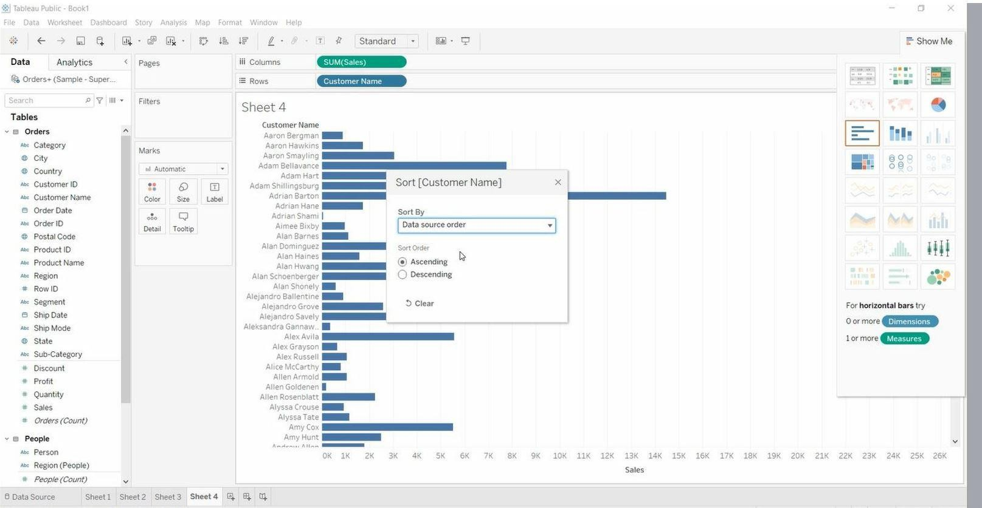

Right Click on **Customer Name** in Graph > Select **Ascending**

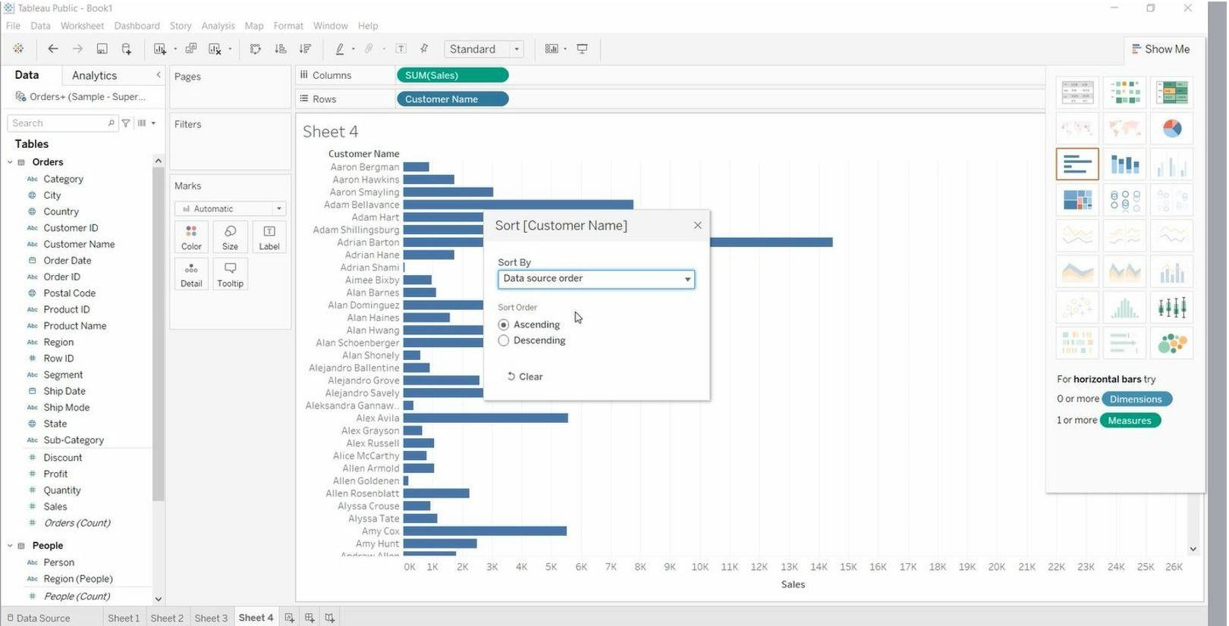

Right Click on **Sales** in Columns > Click on **Filter**

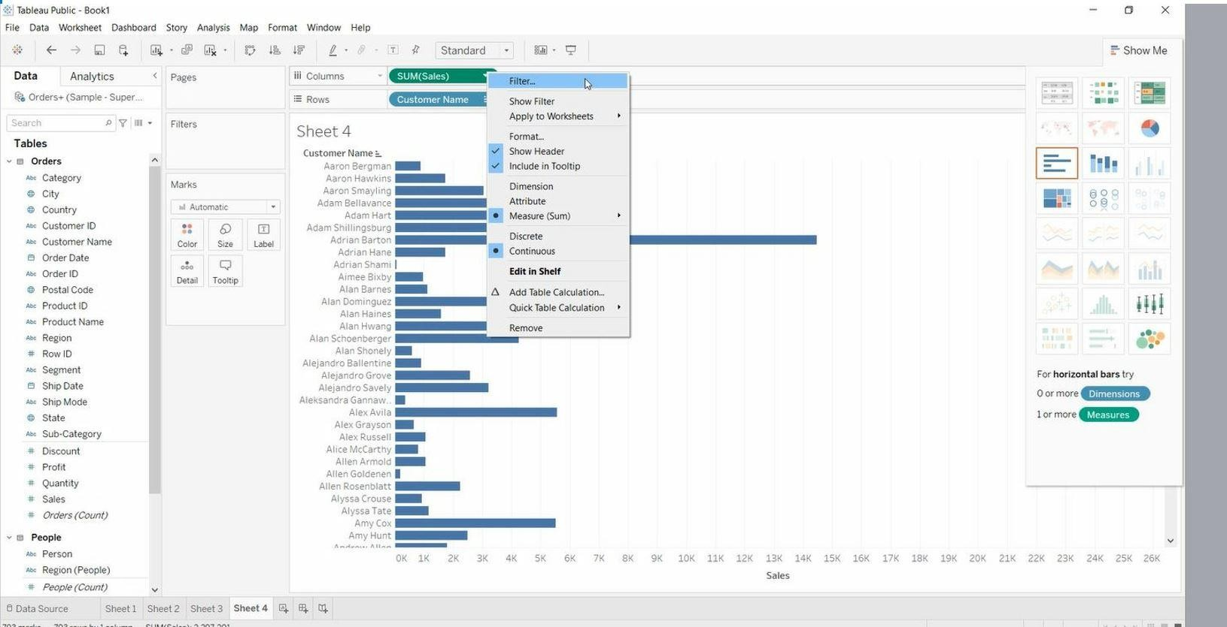

Select **Range of Values,** Set Range > Click on OK

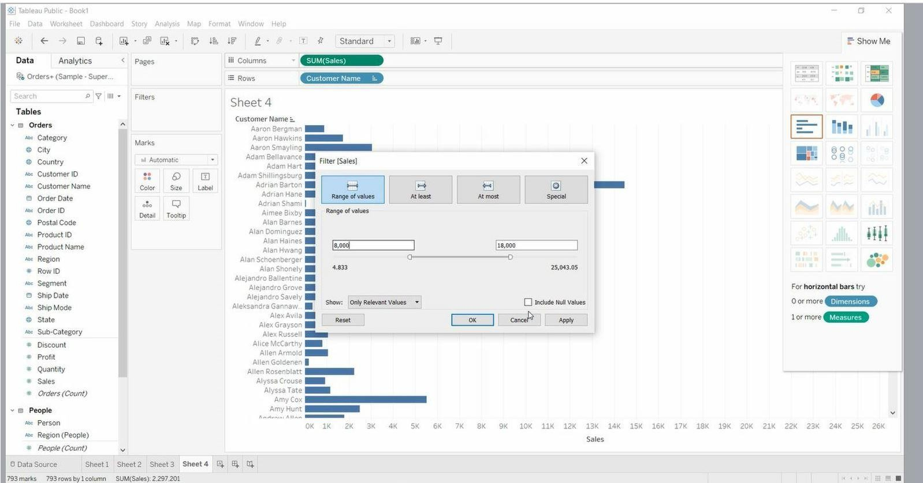

Drag “**Sales**” into Label (Marks card).

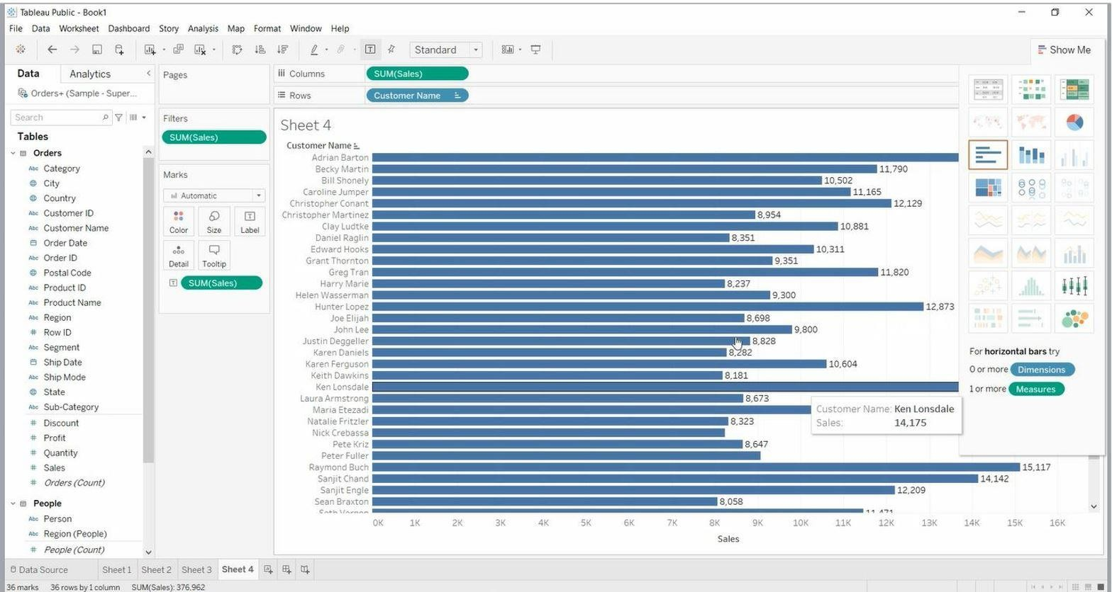

Right Click on any customer name > Format

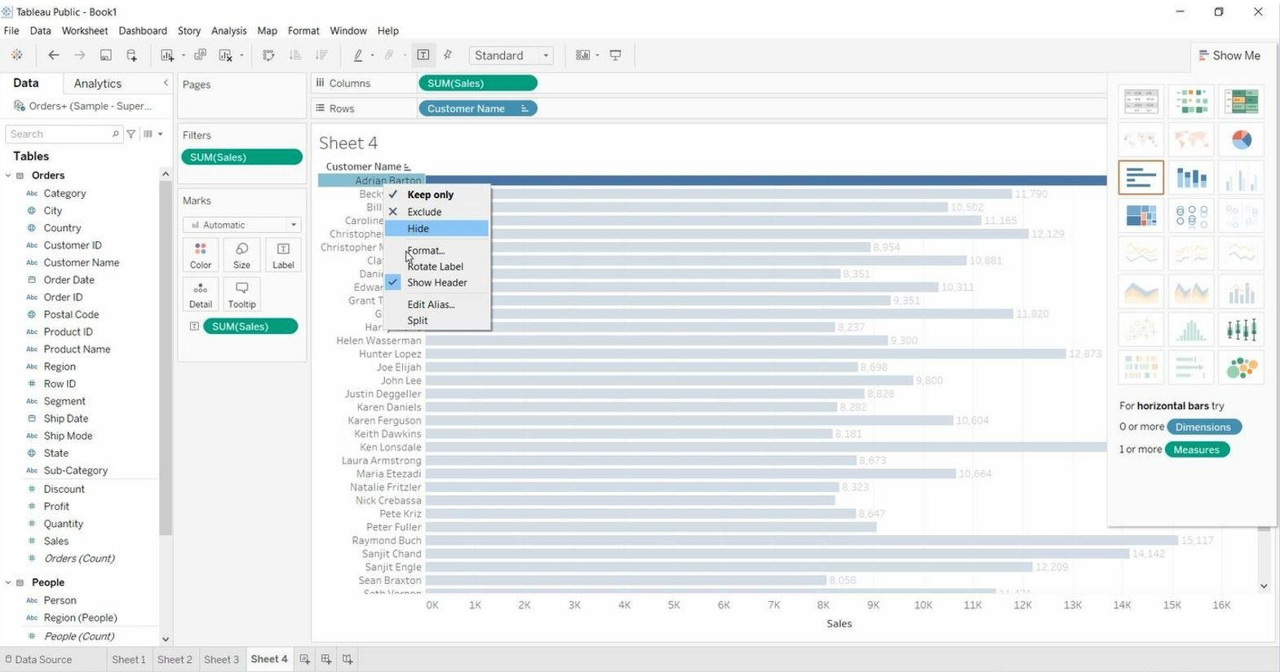

Make Changes

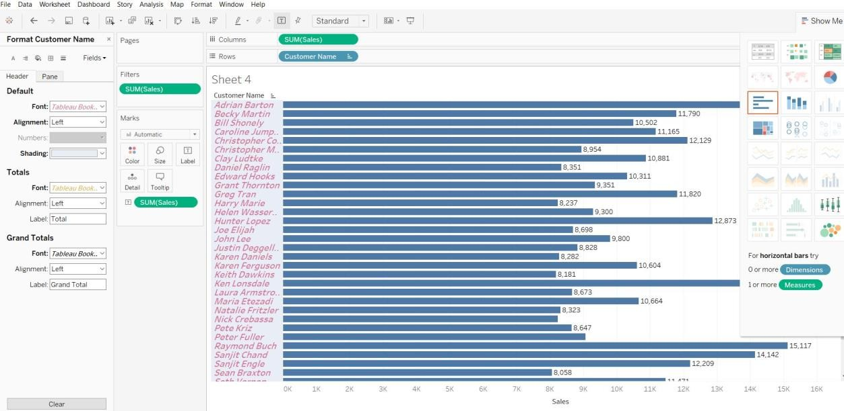

Right Click on **“x-axis”.**

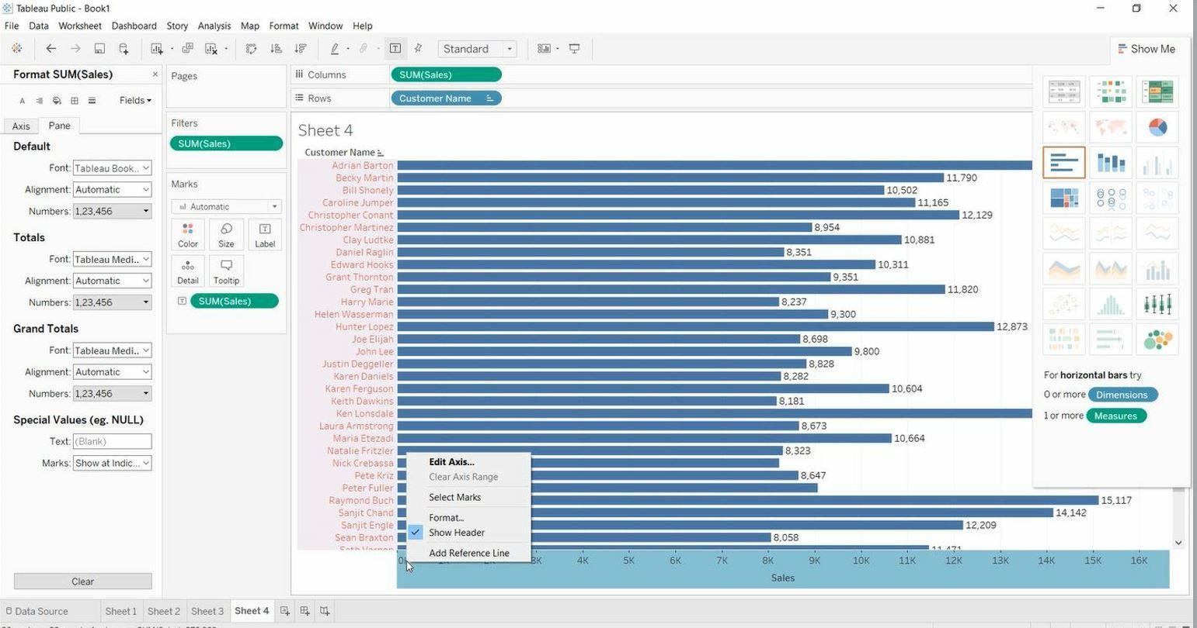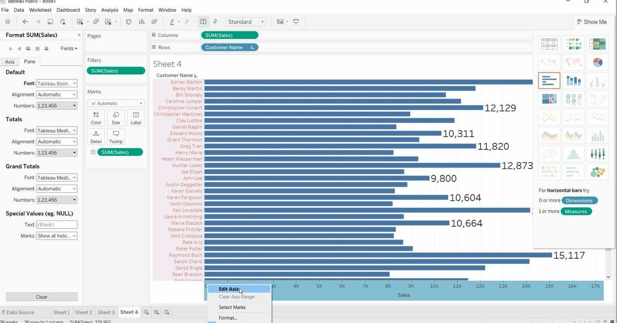

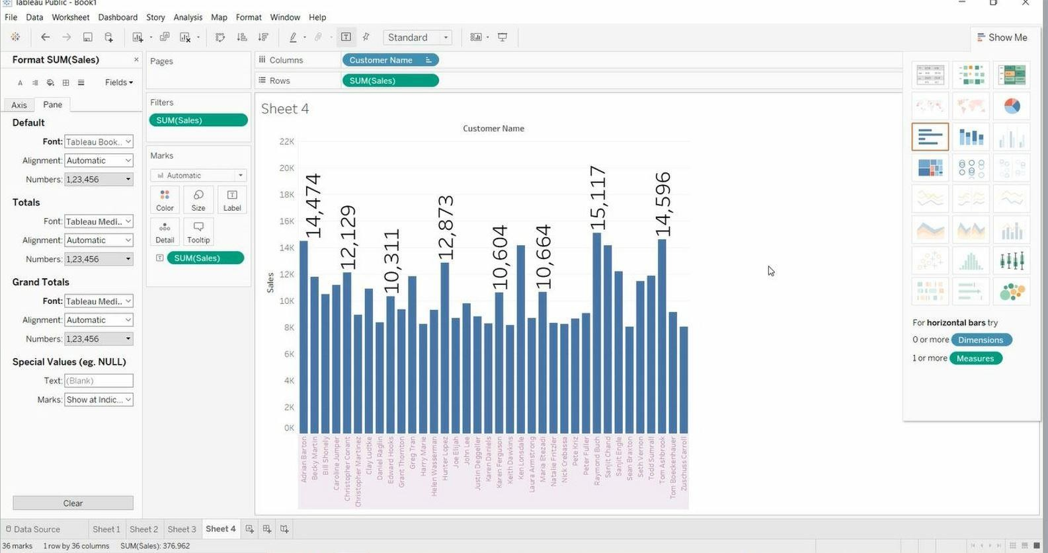

Right Click on **Customer Name** in Rows > Click on **Filter.**

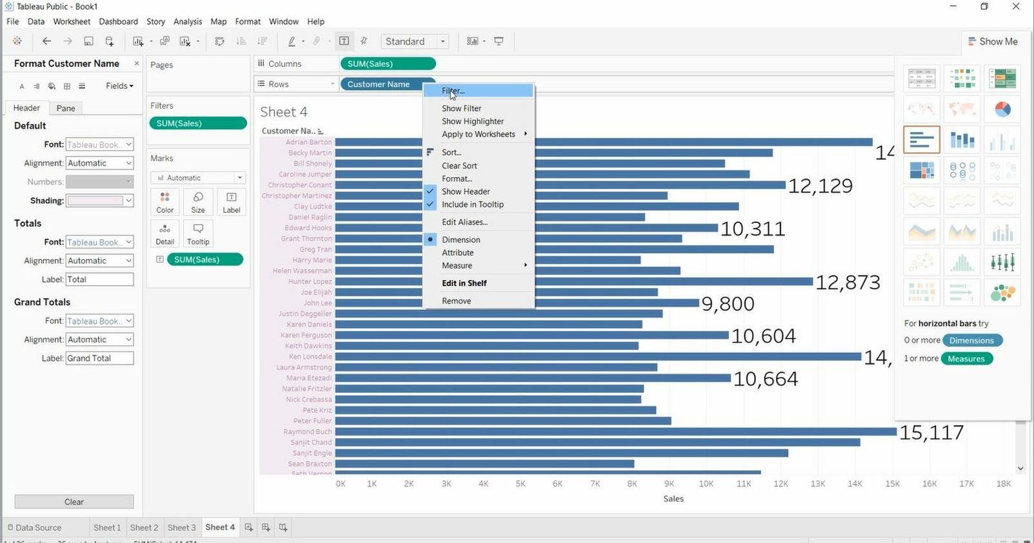

Select **Selected from list**

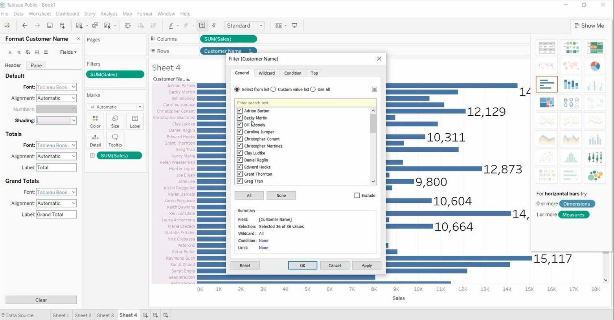

Select 5 or 10 customer from list > Click on **Ok**

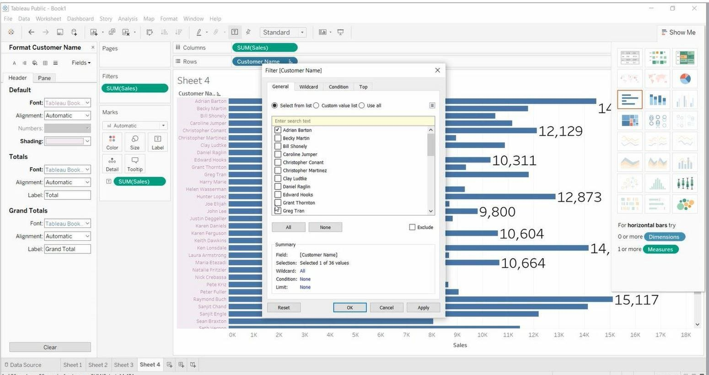

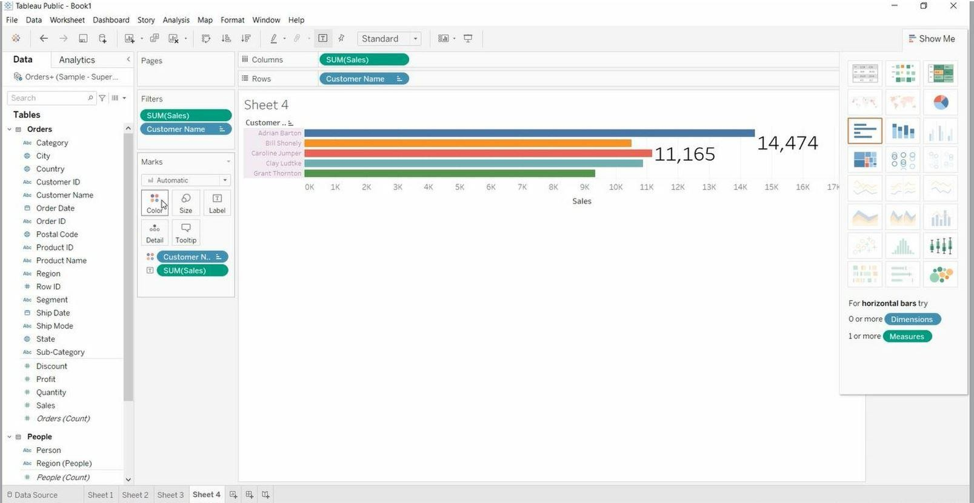Drag “**Customer Name**” into Colour (Marks card).

Right Click on **Customer Name** in Rows > Select Wildcard tab > Set Match Value > Ok

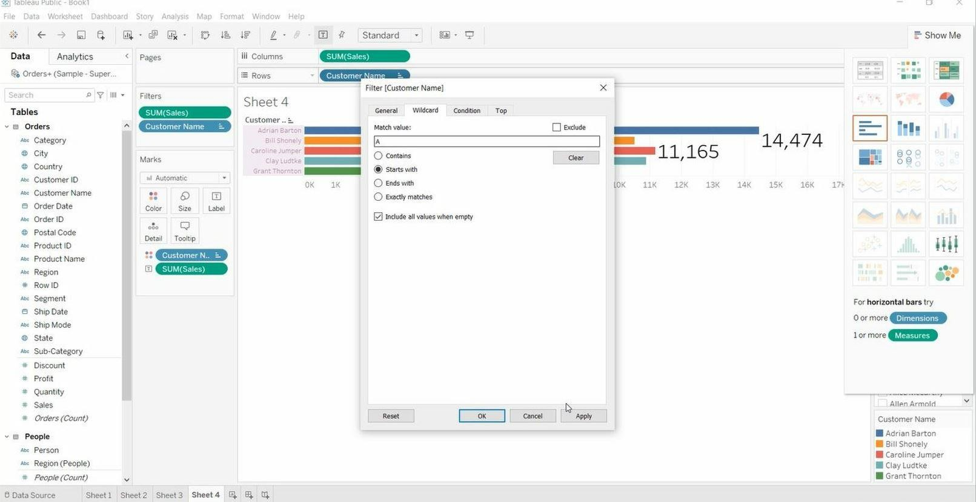

Remove Filter from **Customer Name**

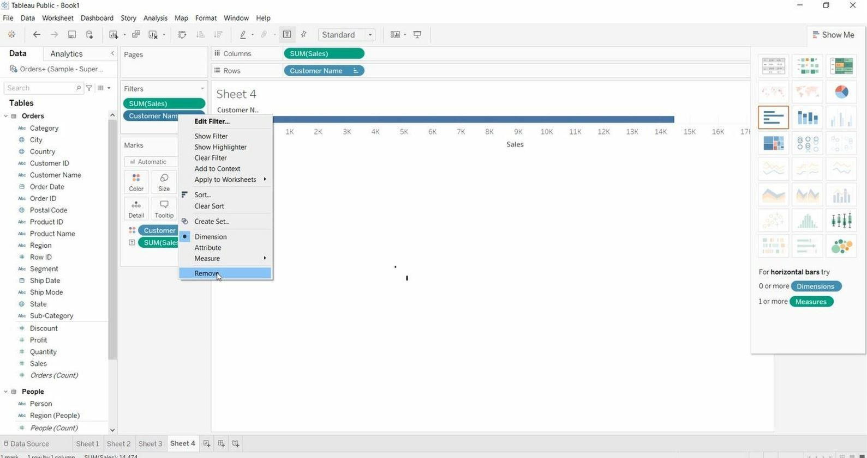

Right Click on **Customer Name** in Rows > Condition tab > Enter Condition Value > Ok

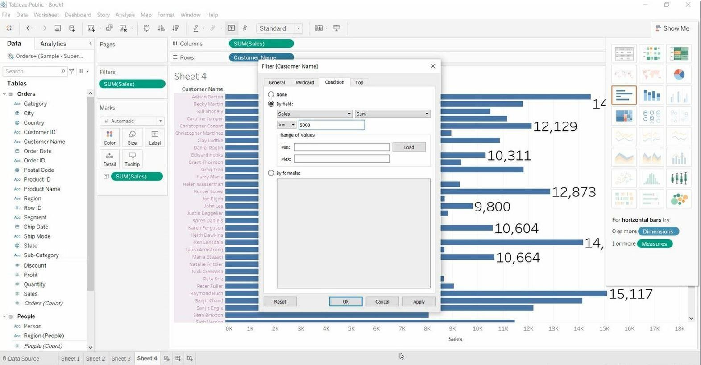

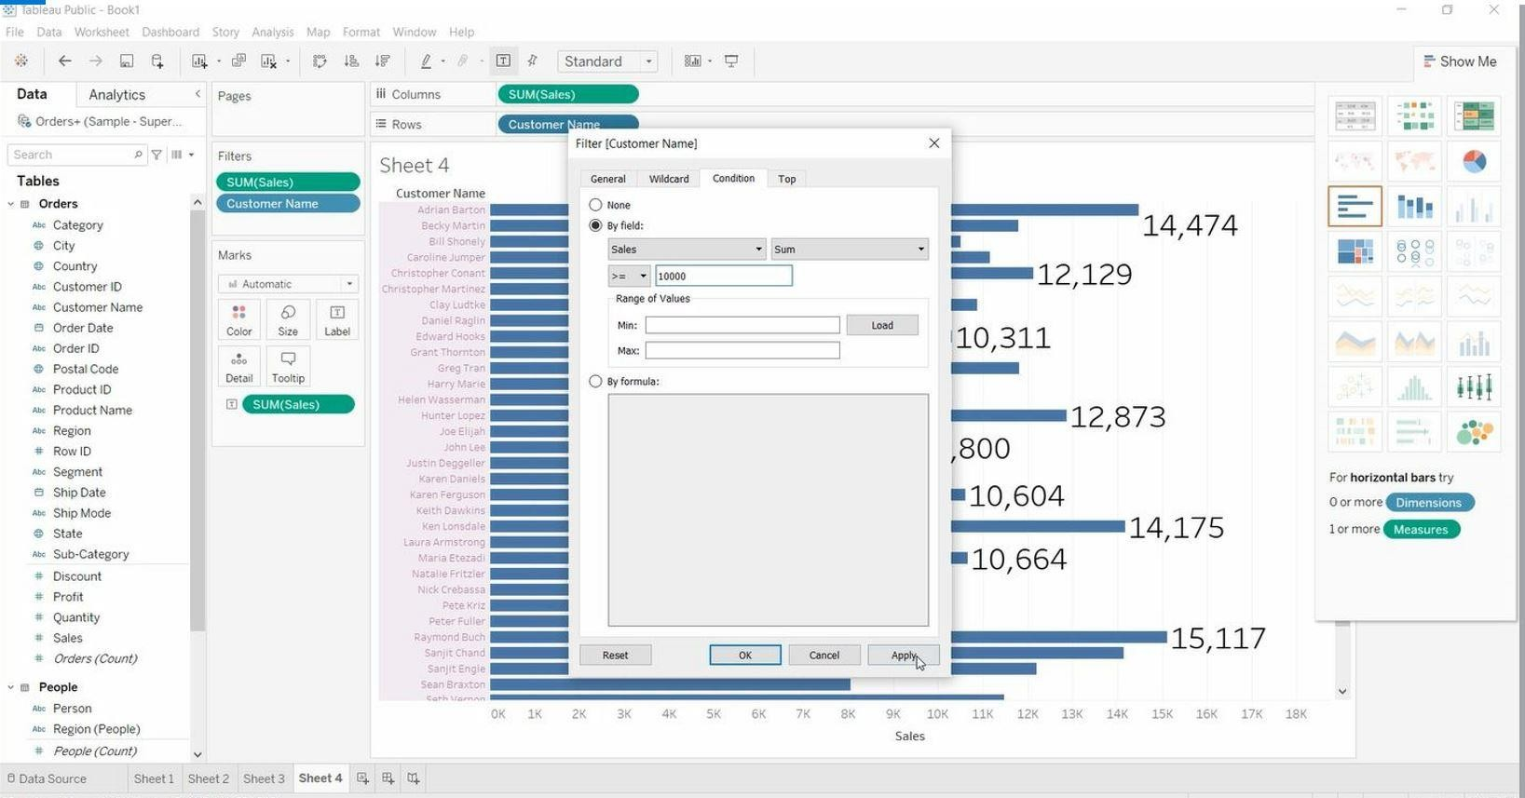

* + Open Tableau public and connect to the data source.
  + Go to the new worksheet.
  + Drag **Sub-Category** into rows and **Order Date** into columns.

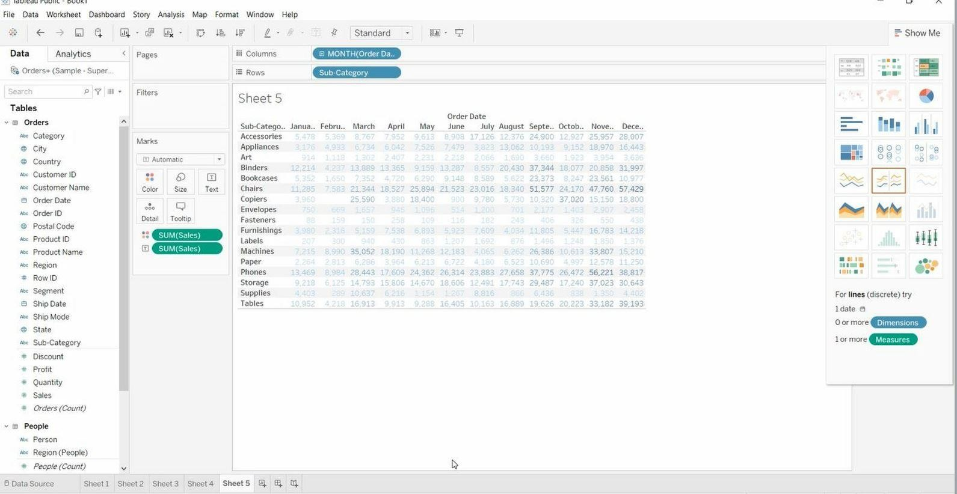

Drag “**Sales**” into Colour & Label (Marks card).

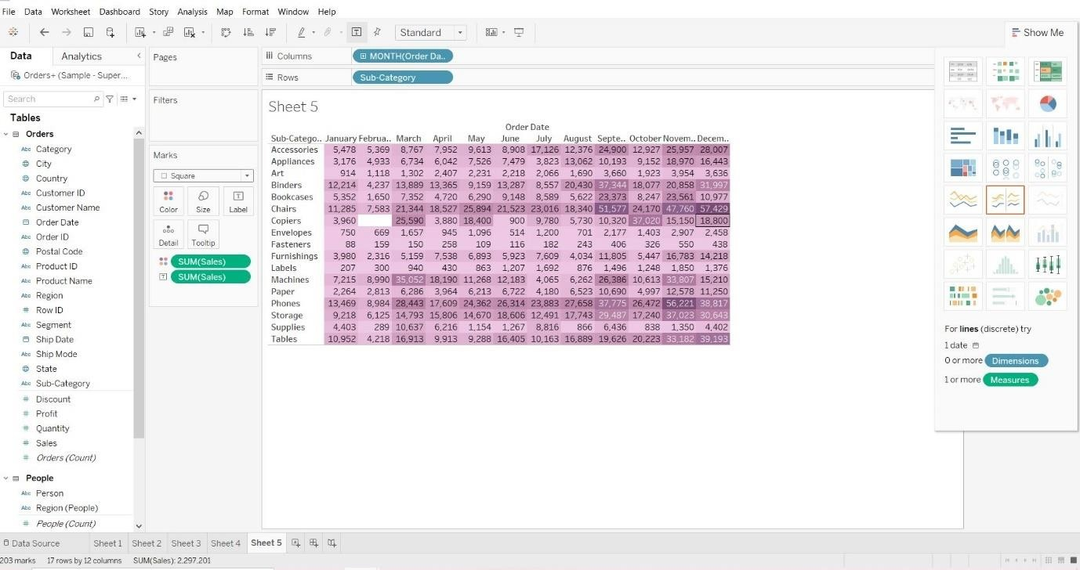

Remove **Order Date** from Columns and **Sales** from Marks Card.

## Tree Map:

Drag “**Profit**” into Colour (Marks card).

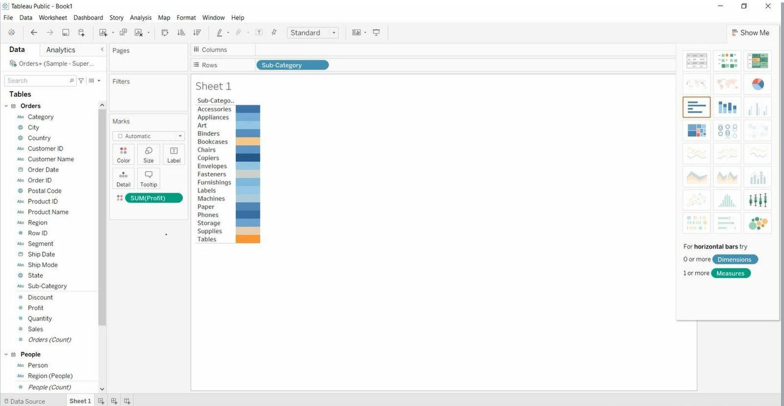

Drag “**Sales**” into Size (Marks card). Drag “**Country**” into Detail (Marks card). Drag “**State**” into Detail (Marks card).

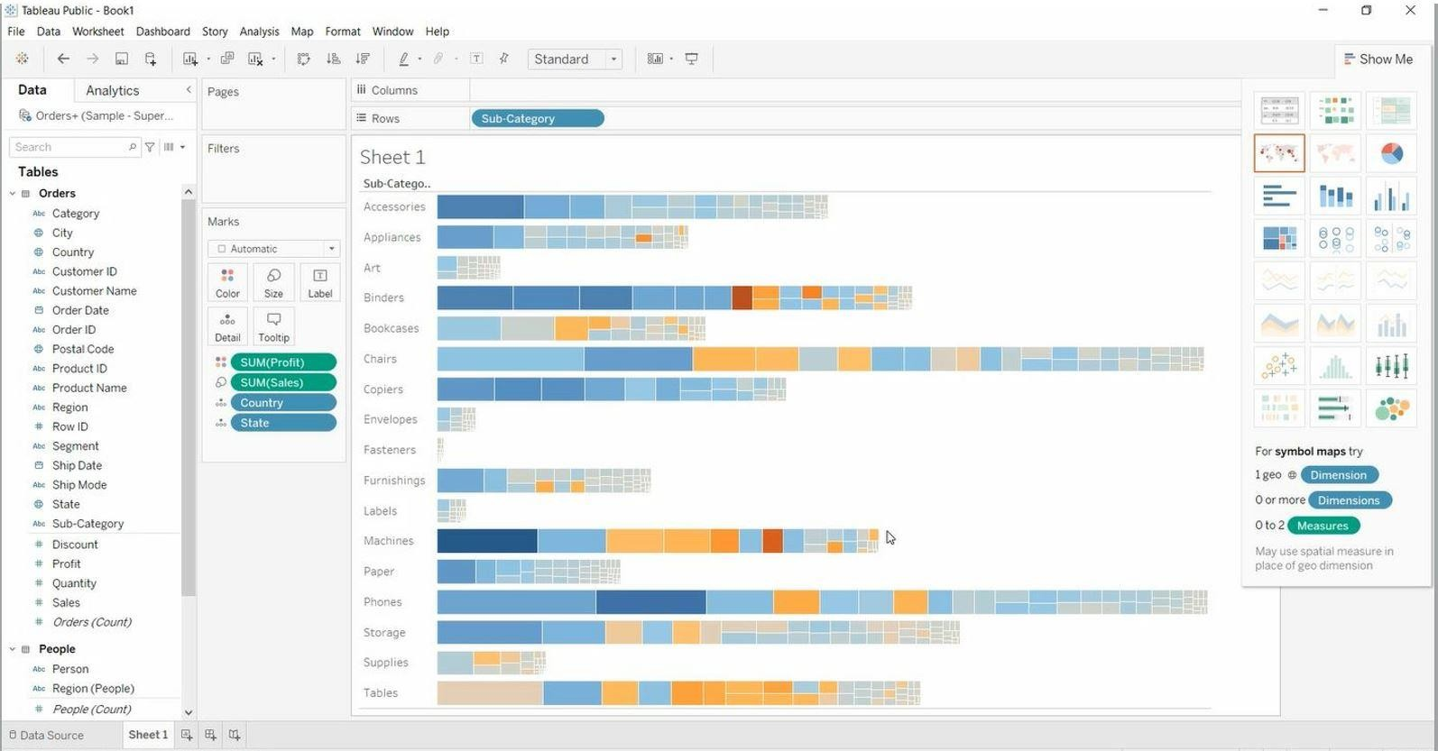

## Spike Chart:

* + Open Tableau public and connect to the data source.
  + Go to the new worksheet.
  + Drag **Discount** into rows and **Order Date** into columns.

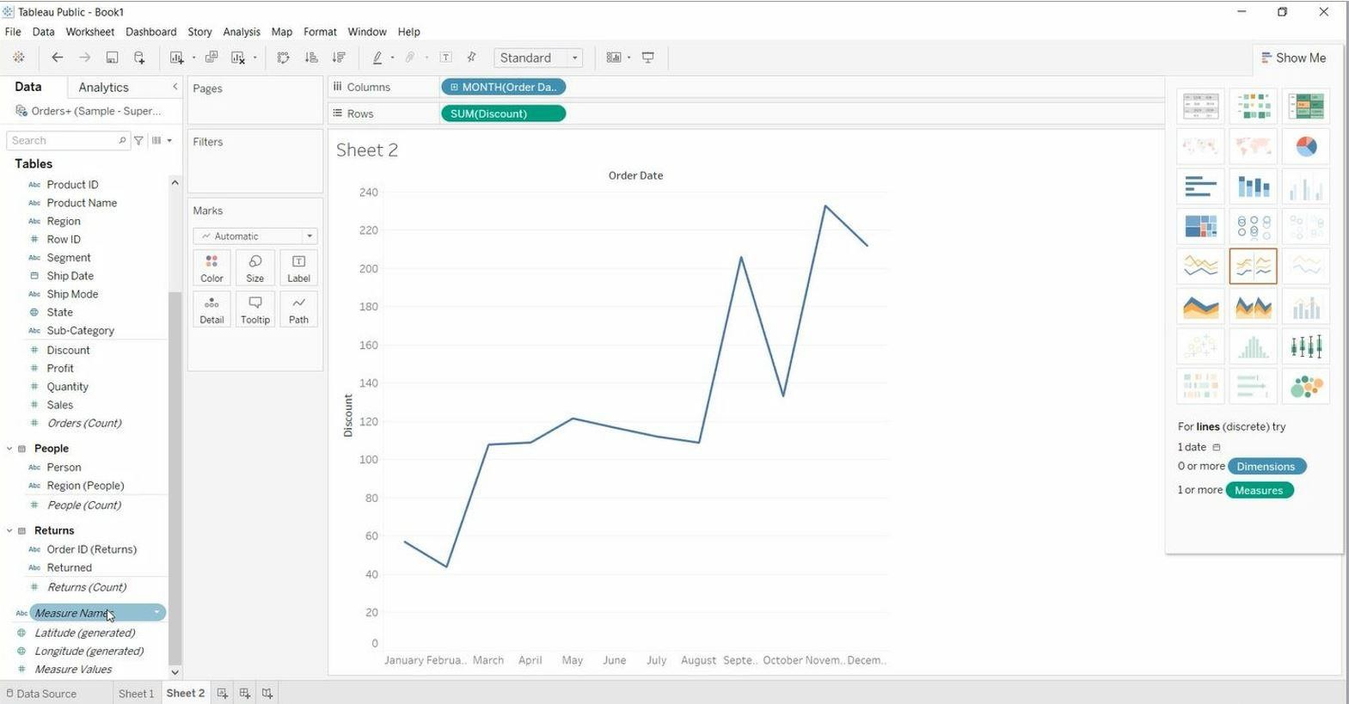

Drag “**Measure Names**” & “**Measure Values**” into Rows.

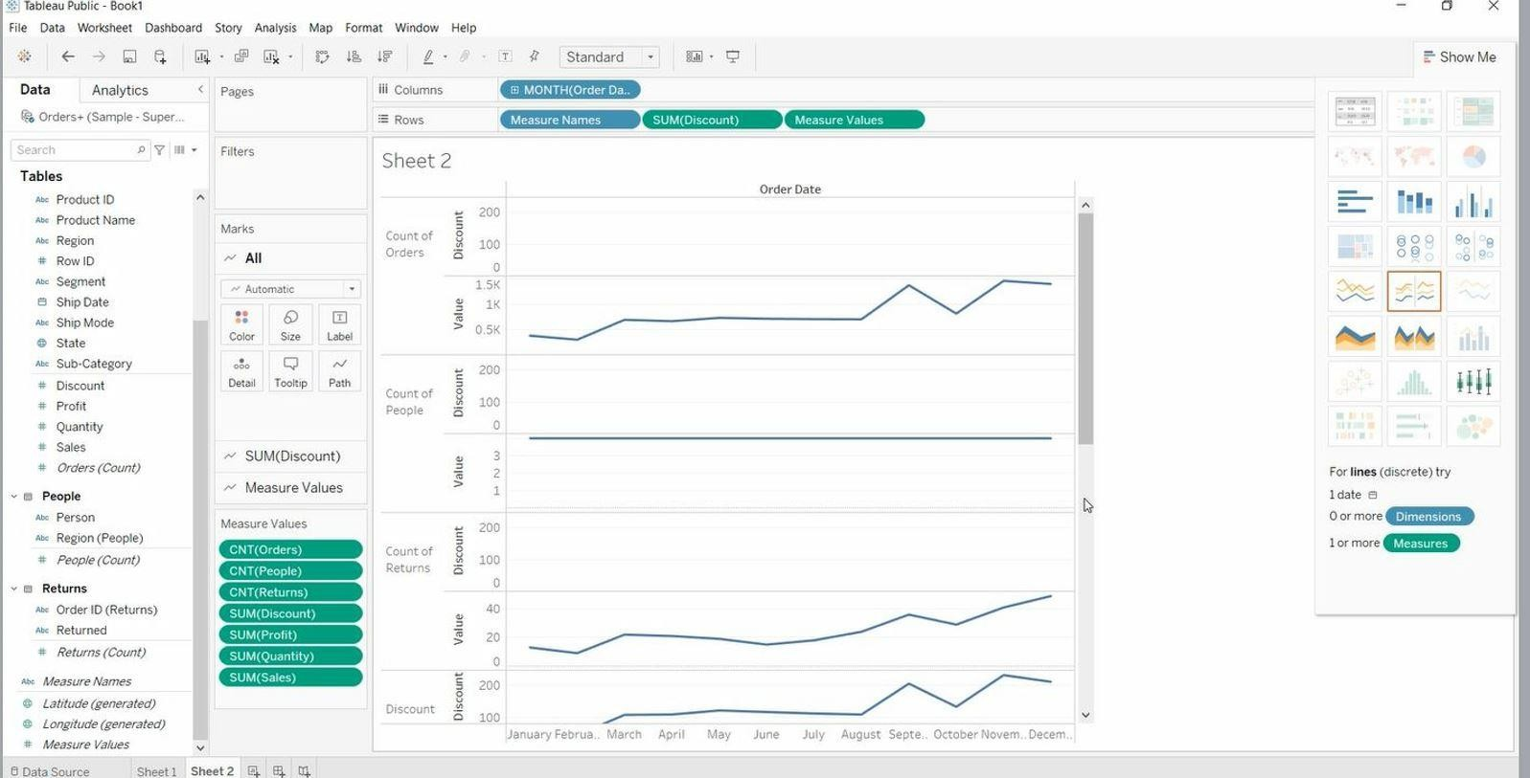

Remove “**Discount**” from Rows.

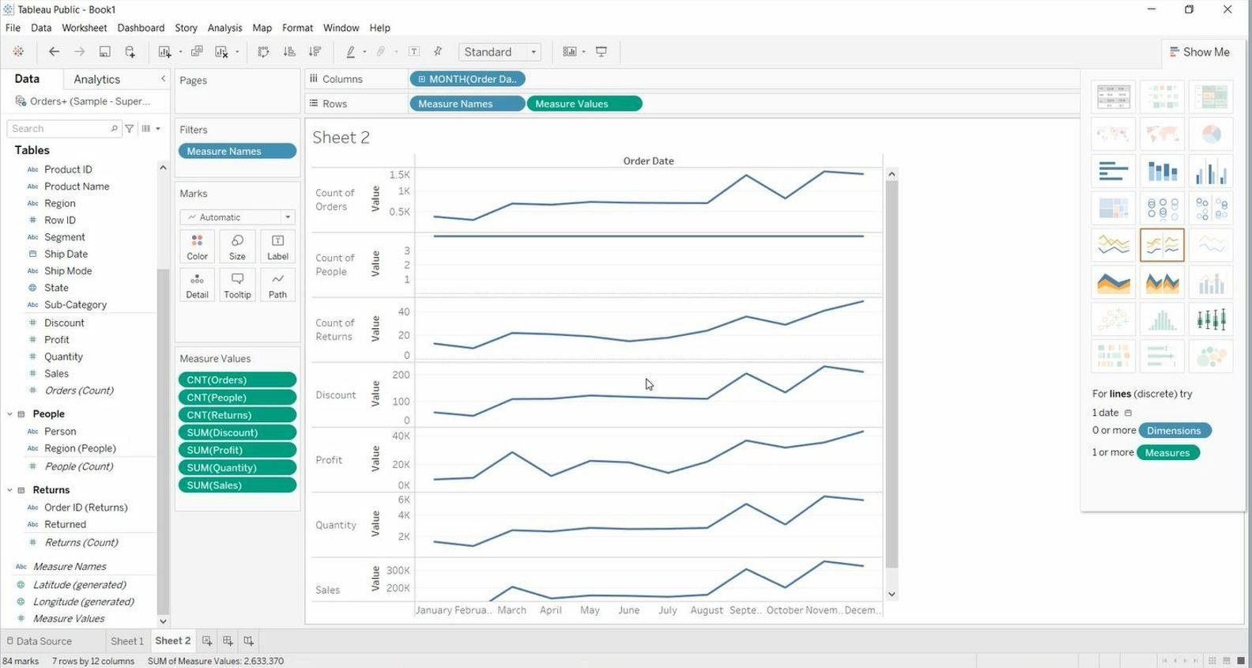

## Bullet Chart:

* + Open Tableau public and connect to the data source.
  + Go to the new worksheet.
  + Drag **Sub-Category** into rows and **Sales** into columns.
  + Right Click on “**Sales**” > Create > Calculation Field.

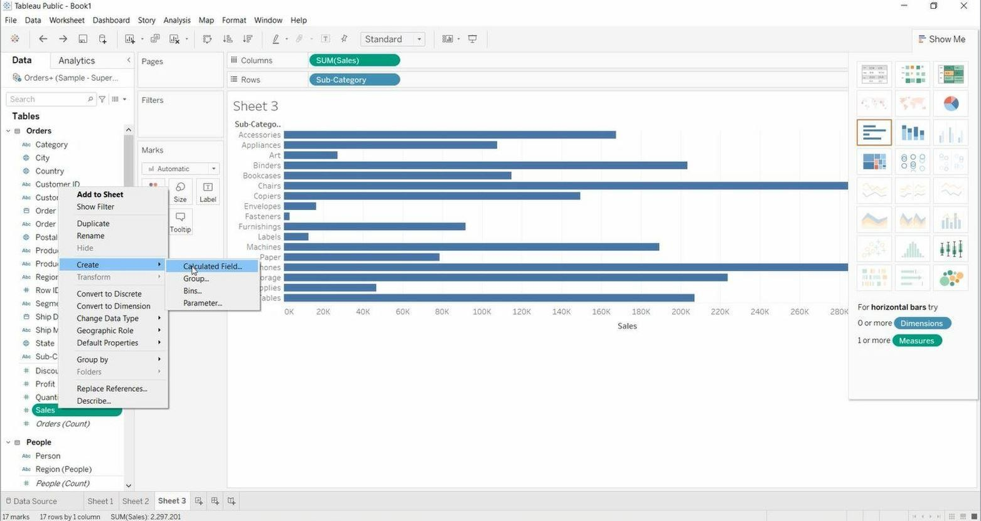

Give any name

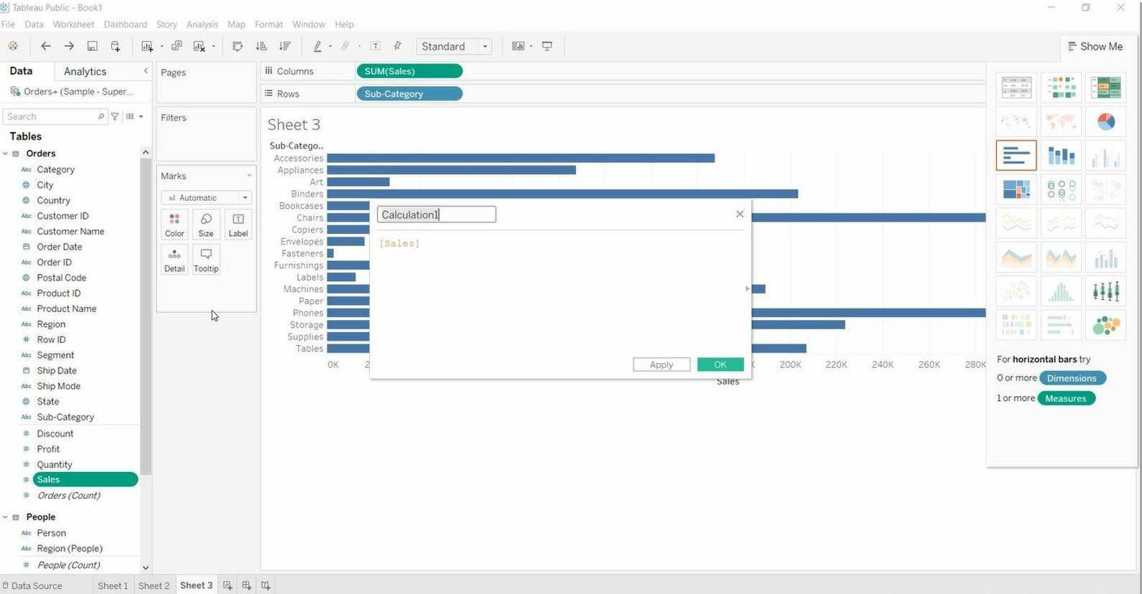

Write the Condition

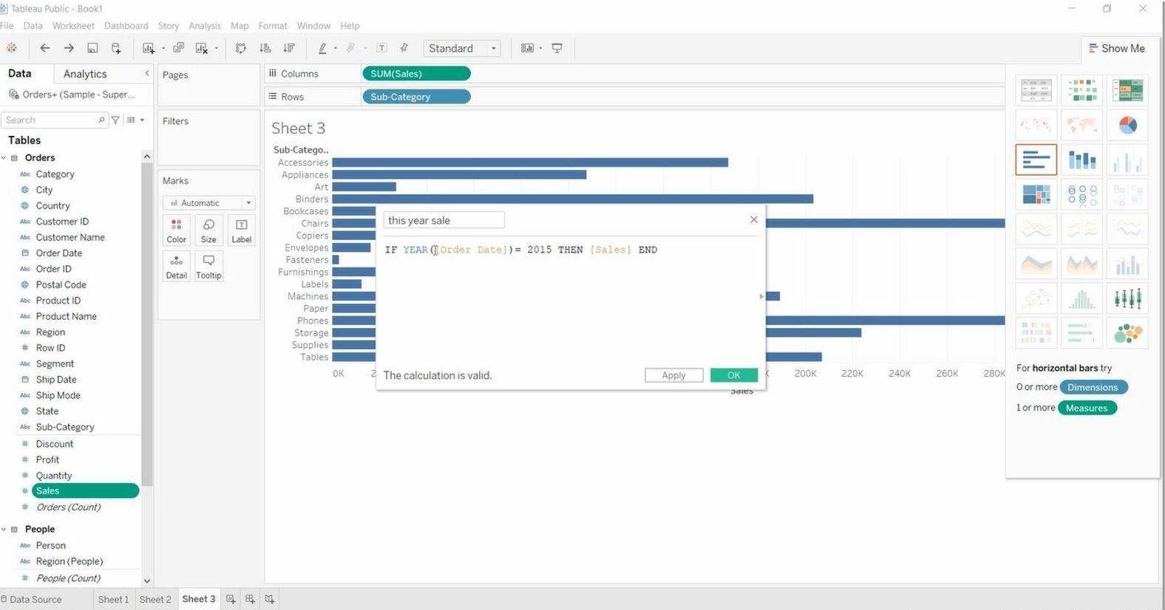

Right Click on “**X-axis**” > Add Reference Line

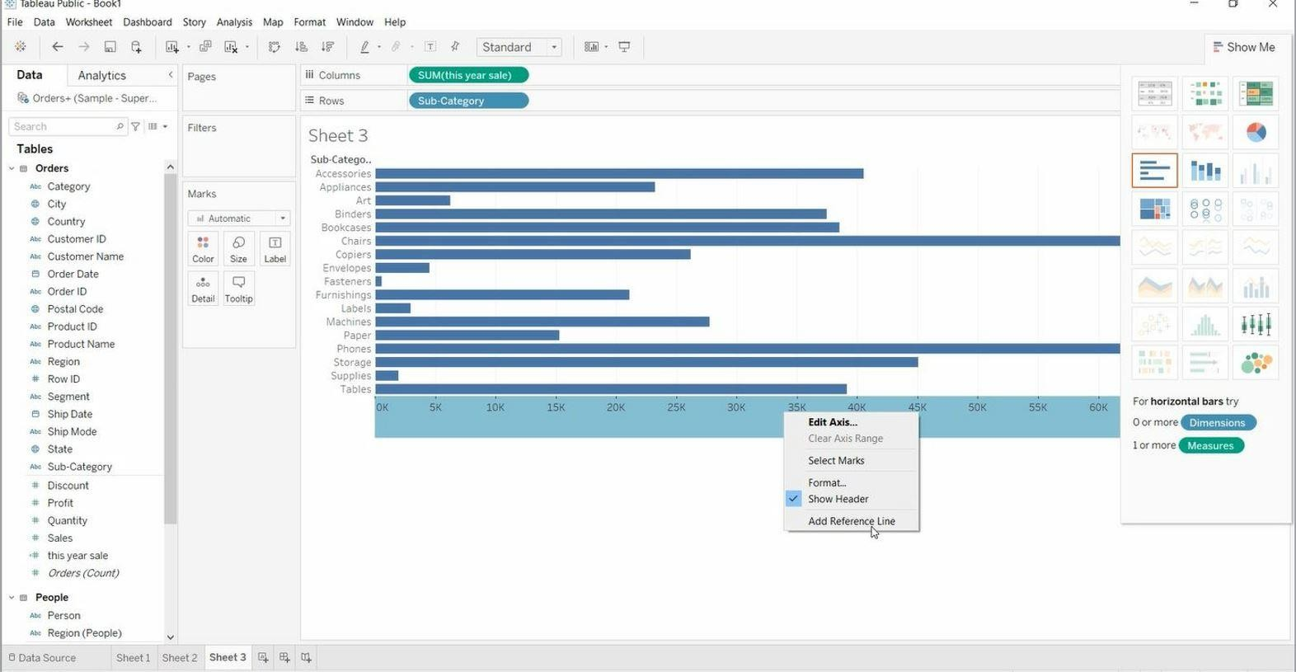

Select “**Line**” > Per Cell > Change Line Colour and Width.

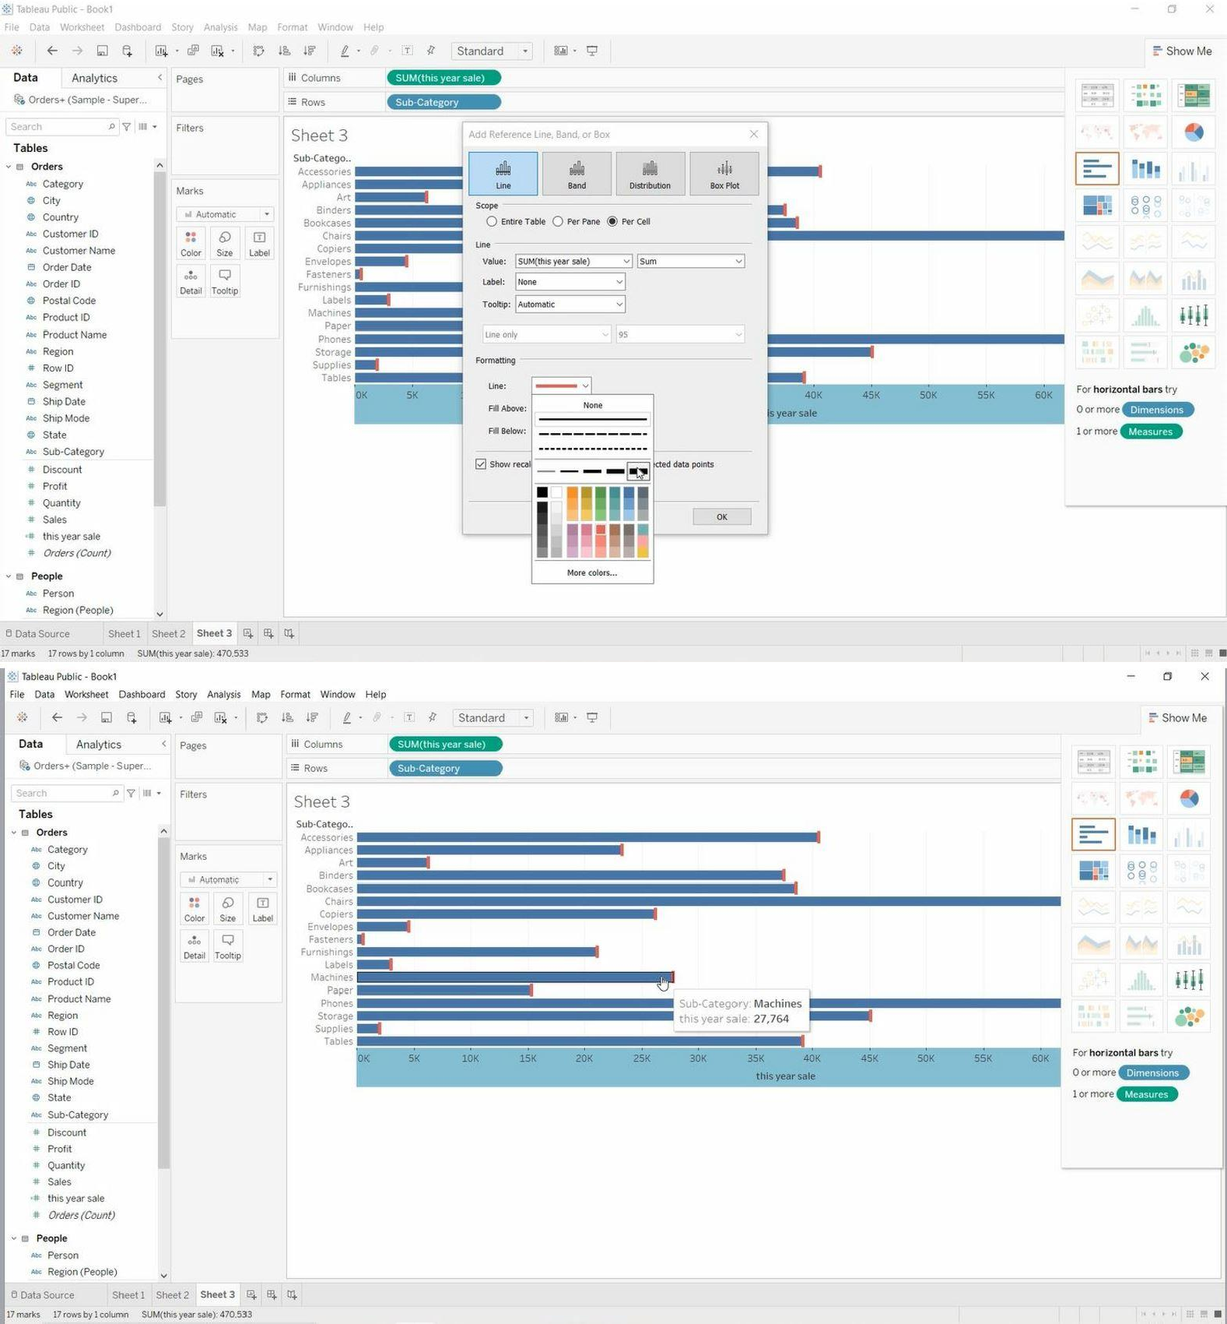

Drag “**Sales**” into Columns.

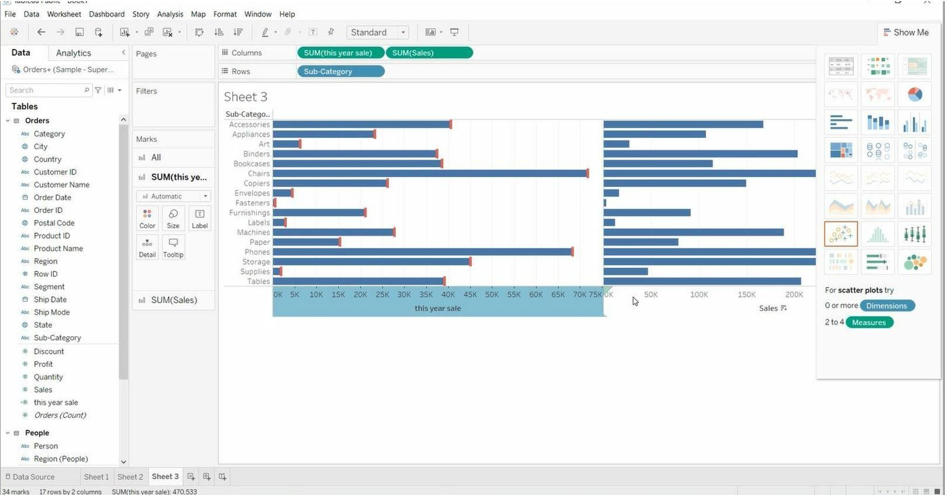

Drag “**Order Date**” into Columns.

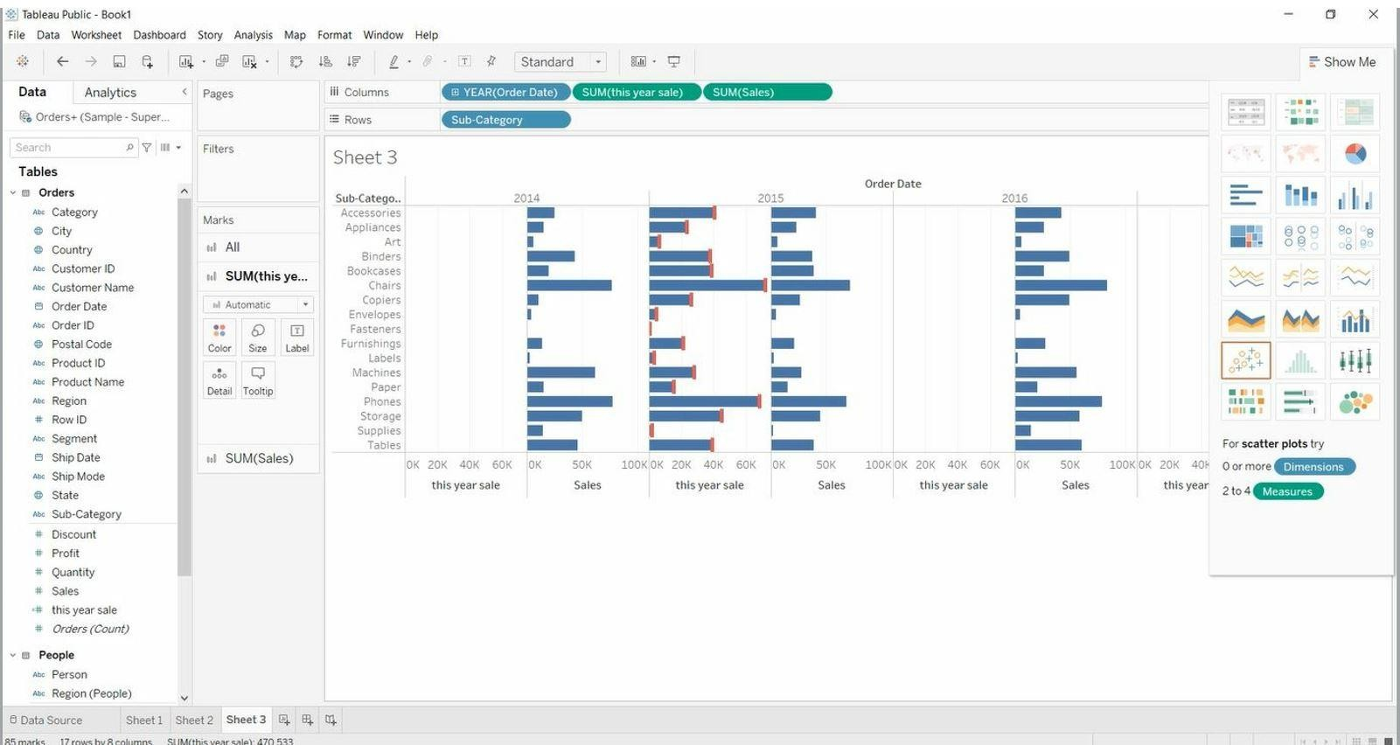

Remove “**Sales”** from Columns.

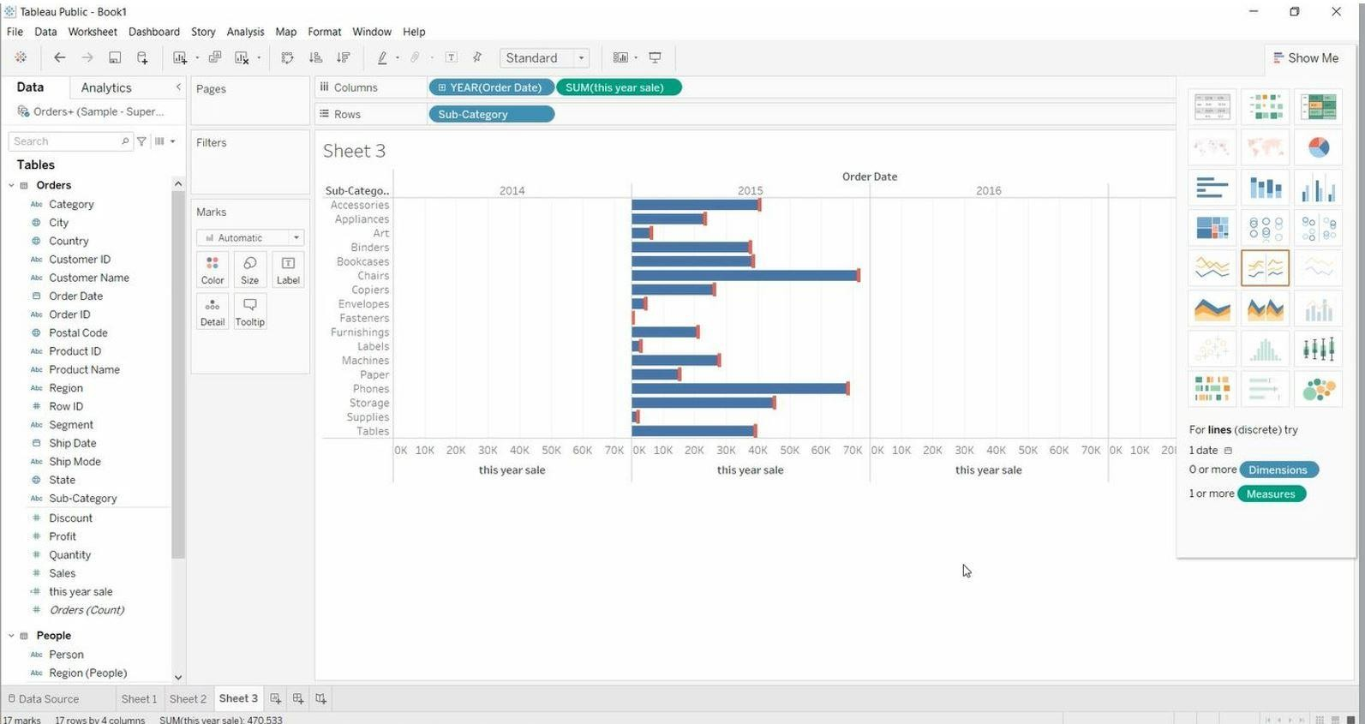

## Map Chart:

* + Open Tableau public and connect to the data source.
  + Go to the new worksheet.
  + Drag **Longitude** into rows and **Latitude** into columns.
  + Drag “**Sales**” into Size (Marks card).

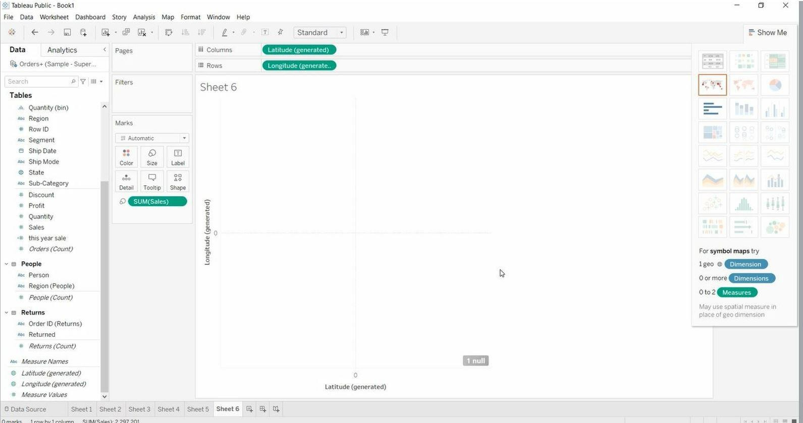

Drag “**Country**” & “**Postal Code**” into Detail (Marks card).

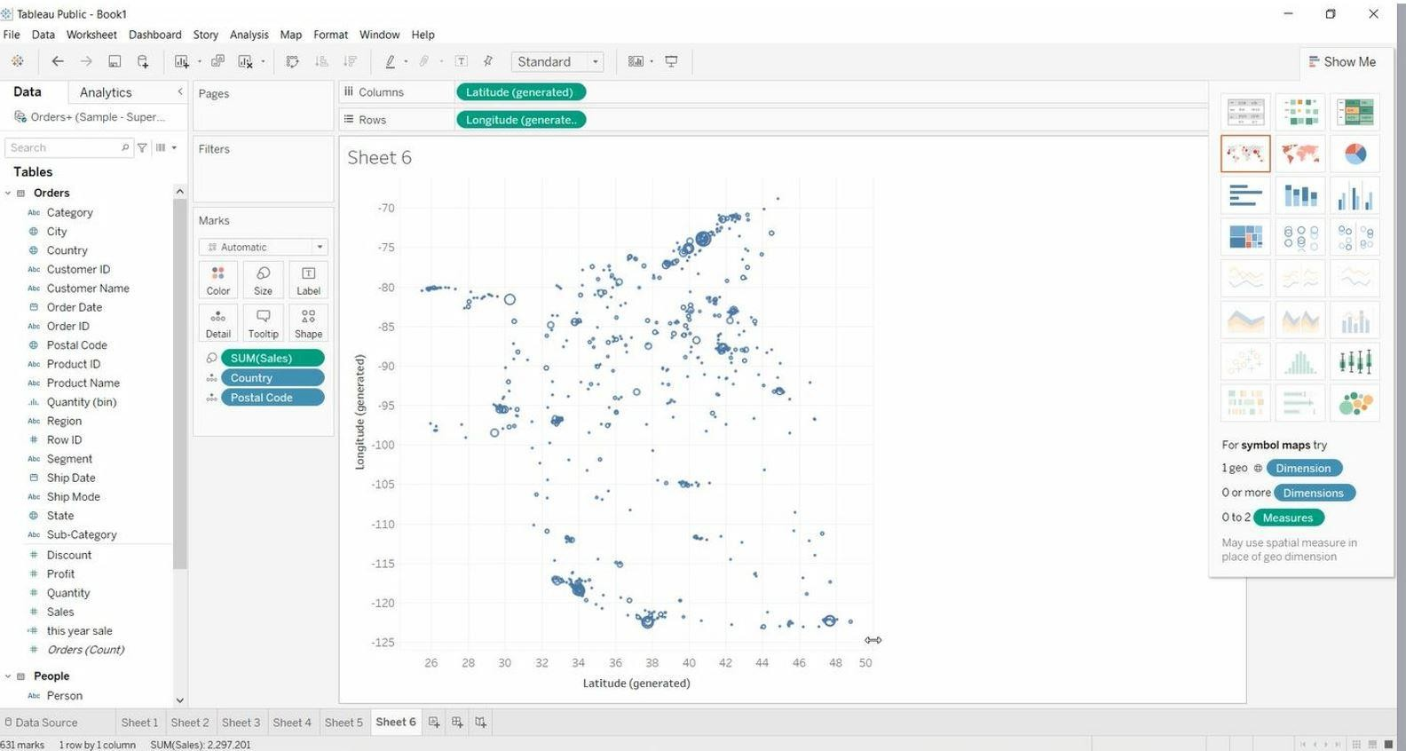

Drag “**Sales**” into Colour (Marks card).

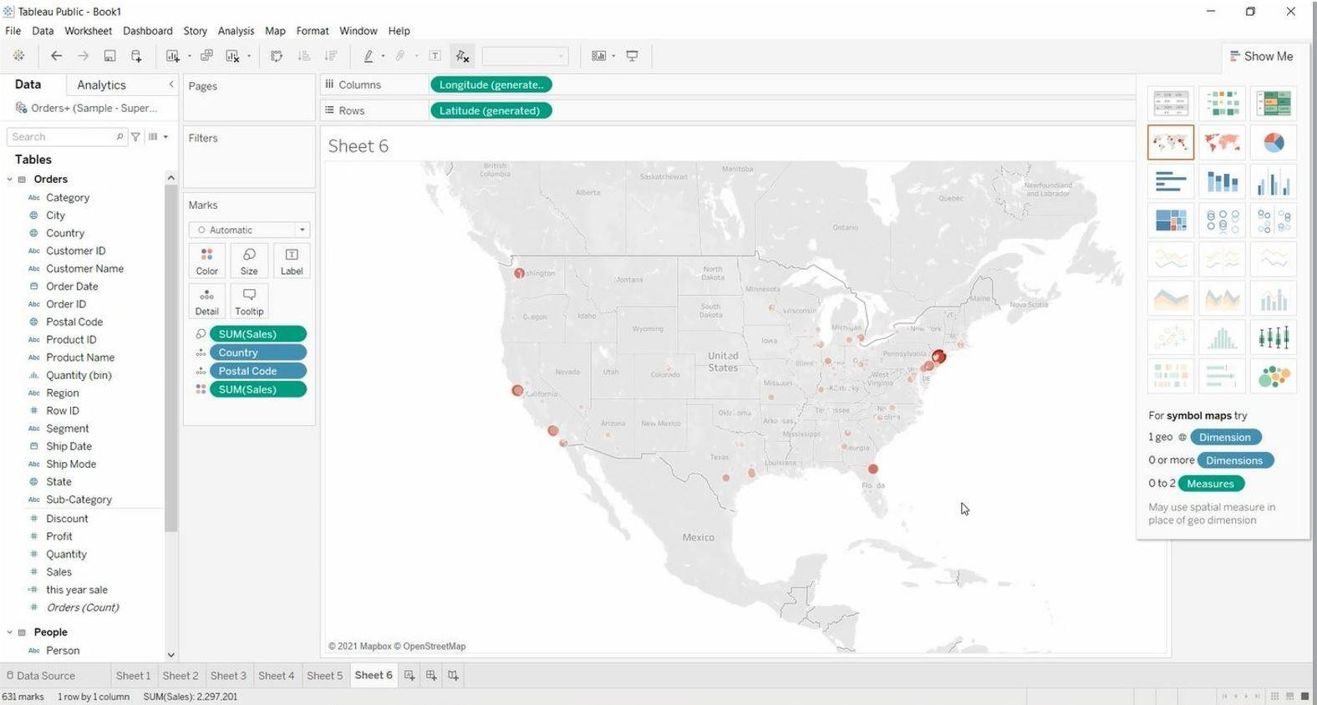

Remove **Postal Code** & **Sales** from Marks Cards. Drag “**State**” into Detail (Marks card).

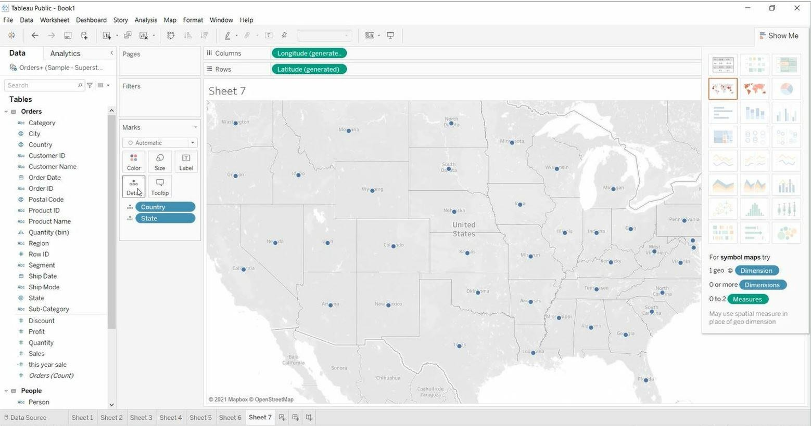

Drag “**Region**” into Colour (Marks card).

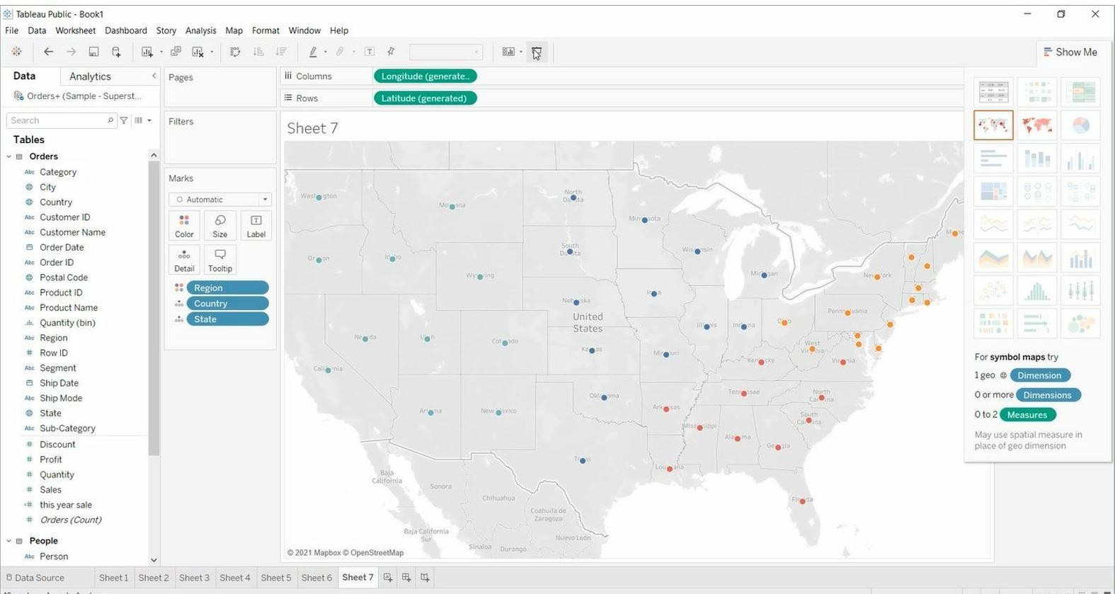

Remove **“Region”** from Marks Card. Drag “**Region**” into Rows.

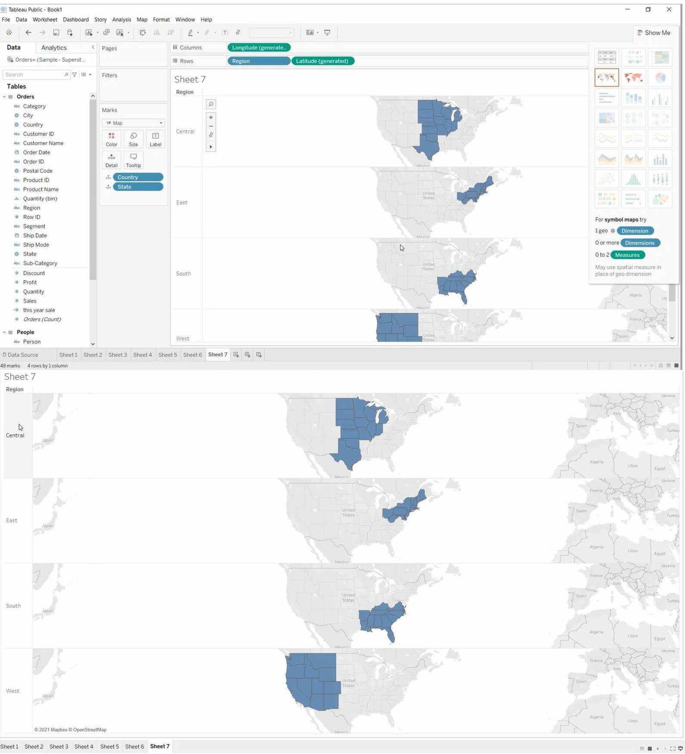

Drag “**Region**” into Colour (Marks Card).

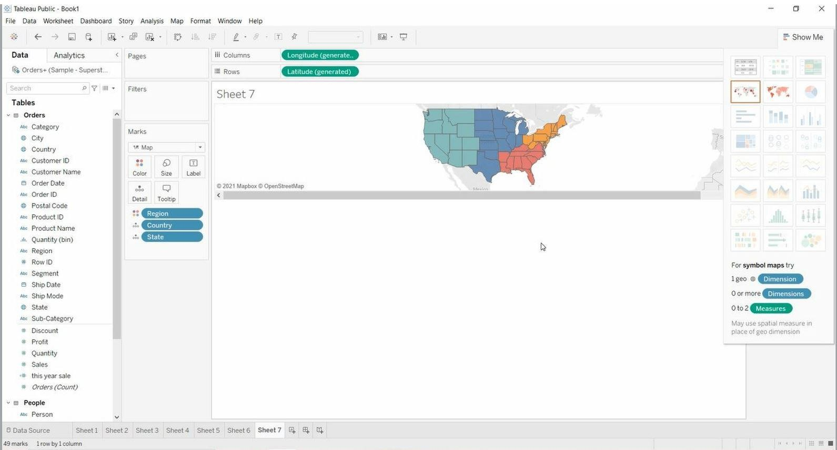

Drag “**Latitude**” into Rows.

Right Click on **Latitude >** Click on **Dual Axis**.

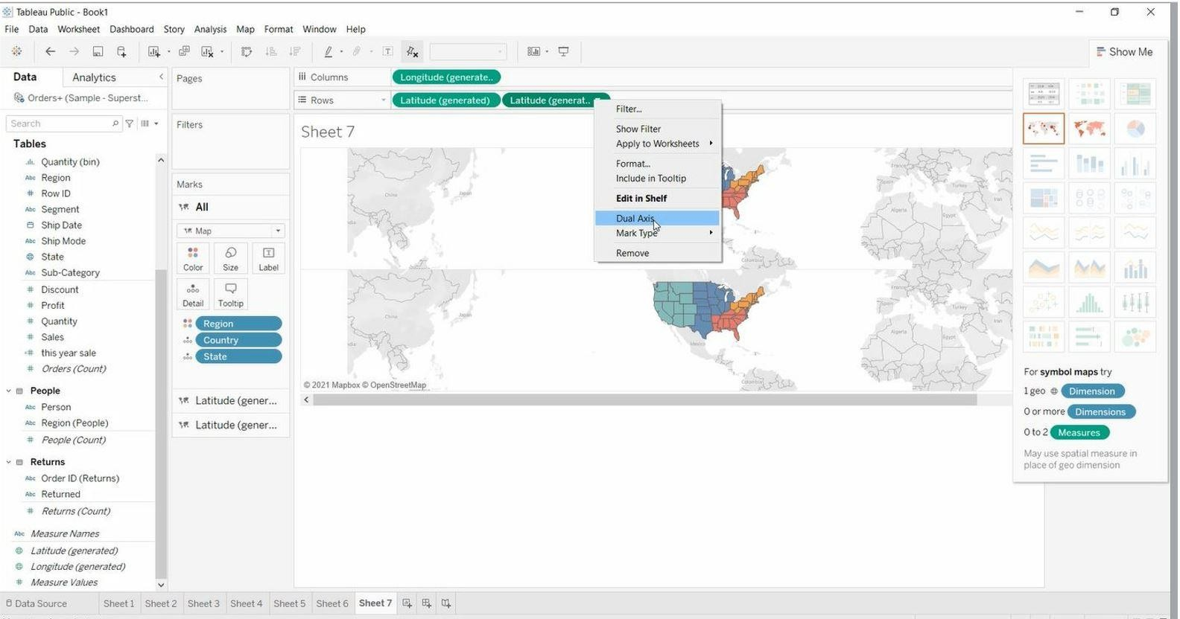

Remove **“Region”** from Marks Card.

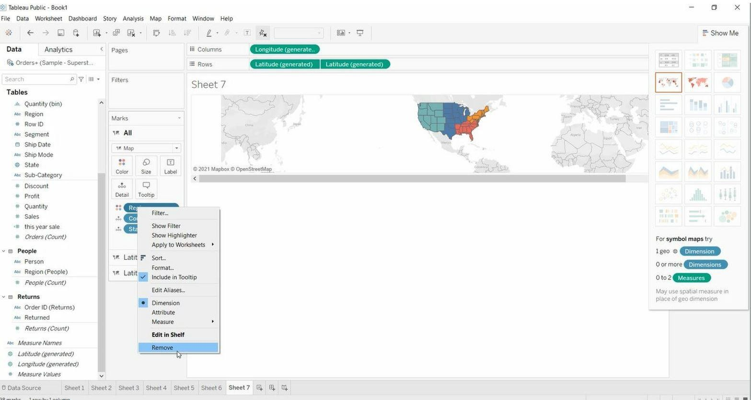

Drag “**State**” into Colour (Marks Card). Drag “**Sales**” into Size (Marks Card).

Drag “**City**” into Detail (Marks Card).

